**ANALYSIS**

**Project Overview:**

The Game:

The project I am making is a game using the language pygame, the game itself is Flappy Duck. It is a game where there is a duck with 1 simple and intuitive control which makes the duck jump. To make the game itself enjoyable there will be different obstacles that will act differently that if they hit the user, the user loses. The point of the game is to get the highest score possible; the player gets 1 point for every 2 seconds of survival.

**Computer:**

How is it solvable by computational methods:

It’s a good idea to use a computer to solve this problem because the problem itself is only solvable on a computer as it is meant to be a computer game. As the user needs to interact with the program for the program to function as it requires user inputs for events to occur.

It stores a lot of data like character velocity, provides an interface, generates obstacles etc.

It also requires repeating data and running loops (Iteration), which makes it suitable for a computer. Making it a computer game also means that it allows the solution to be accessed from anywhere, at a quick moment as it doesn’t require the hassle of finding it in certain stores or having to be at a certain location to play it etc. All a person needs is a computer to be able to use the program.

Computational Thinking:

Decomposition can be used to break the problem down into smaller parts, for example breaking down Flappy Duck into: background, character, obstacles, score etc. Pattern recognition can be used as problems such as character and obstacles are very similar. Finally Abstraction can also be used as instead of making the character have realistic movement it just flaps its wings instead of going looking up and down.

**Stakeholders/Users/Customers:**

Who is it For:

I am making this game for anyone who enjoys challenging games. It will be very accessible and doesn’t require a lot of the user's time to play so it can be played during a break but it can also be played for long periods of time if the user wishes too. The game can be played by anyone, there will be no language barriers as the user does not have to read anything and for the restart game I will add a restart button using the international restart symbol, there will be no age barrier as the game doesn’t contain gore or swearing or violence. However, the user will require a computer to play the game meaning that there is a cost barrier present. But the game should be able to run in pretty much most modern systems or a lot of older systems as it doesn’t require good hardware specifications to run the game, the game itself is also free to play. Even though the game itself is challenging, that doesn’t mean that it is a barrier as the game itself has very easy controls that anyone could use including very young children and the elderly.

Certain Stakeholders:

|  |  |  |
| --- | --- | --- |
| **Stakeholder** | **Benefits** | **Drawbacks** |
| **Friends** | I see them everyday so I can get advice and information about my game regularly. | May not have much interest, but if they do then they might be too nice resulting in less customer - developer coordination |
| **Teachers** | Good detailed analysis about the project itself. | Only see them twice a week and hard to arrange meeting |
| **Family** | Gives me a person who doesn't play games point of view | Don’t know what to expect from games therefore can’t give the best criticism |
| **Clients** | Give me a better vision of what they want the game to be when published | May set expectations too high and set problems that would be too difficult for me to solve in the time I have available |

Friends: “I just want a game I can play during my breaks, when I'm bored and isn't too serious or competitive like League of legends.” My game reaches their needs as it can be used as a game to play to relax and just have fun which does not require time and effort.

Teacher: “A game which can keep me occupied when I’ve finished all my work and a game where I can show programming skills/constructs to other students” My game reaches their needs as it can be played as much as you want and will use a lot of different type of coding skills/constructs such as functions, loops, drawing, generation etc.

Family: “Easy game which even I can play, not long sessions because I'm busy. Cheap also” My game reaches their needs as it is very simple to play and all you need is a computer.

Clients: “A game where I can compete for a high score and showcase my skills and improve over time to become better” My game reaches their needs as it is a difficult game overall and skill difference can be easily seen.

**Research:**

Existing Programs:

1- Flappy Bird

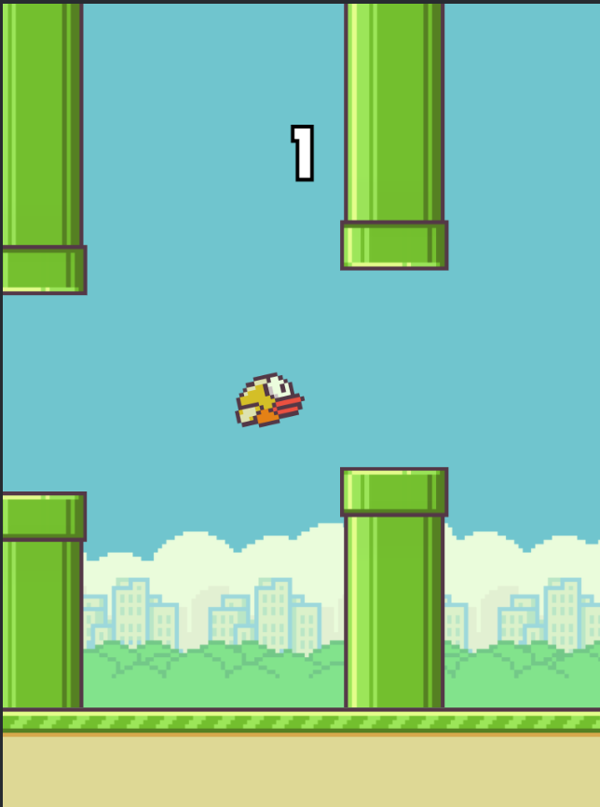

Flappy Bird is the main inspiration for my game, it is a very similar type of game but with different obstacles as in flappy bird there's symmetrical horizontal pipes that if the bird (controlled by the user) hits, the game will end. The score system is +1 point every pipe you pass. The features I plan to integrate to my system are the movement, a simple “duck” which stays in the same row on the screen and can only go up and down with a jump. I will add this as it makes the game simple but difficult at the same time.  I would be adding obstacles but in a different way since Flappy Bird’s pipes seem too generic and makes each time you play feel very similar. Therefore, I will not be implementing their type of obstacles. I will also add a scoring system but yet again different as this scoring system will not work for my solution as there is no “direct” obstacle in my game. A feature I will not add is the way the bird itself looks up and down whenever he jumps/doesn’t jump for a period of time as it just adds extra complexity and confusion that no one welcomes/enjoys.

2- Jetpack Joyride

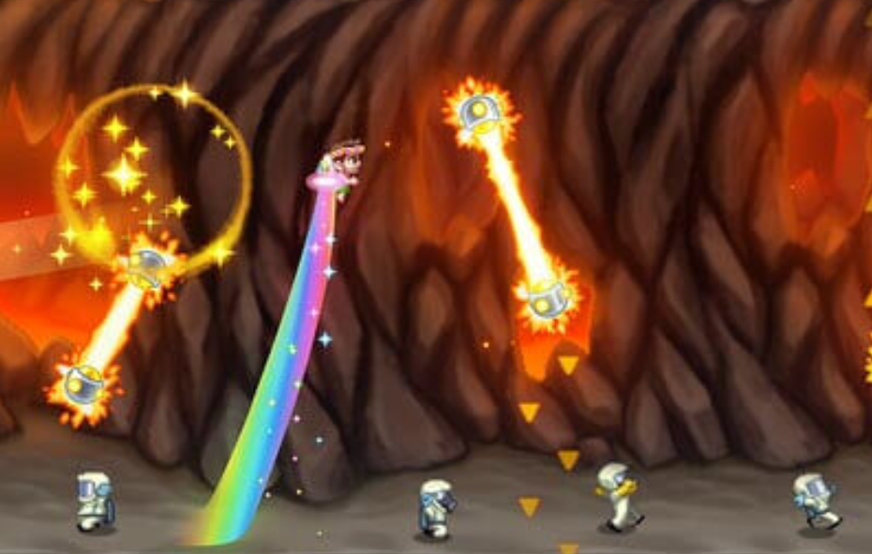

Jetpack Joyride is a game where if you hold a button then you will go up and if the button isn’t held then you start going down. The point of the game is to keep going and to avoid the obstacles on the screen. Coins start appearing on the screen which you can collect and use to buy cosmetics for your character in future runs. When you reach a certain score you enter a new area with new obstacles and it keeps cycling. The features I plan to integrate to my solution are the obstacles and the way they work since I love how even though you're used to the obstacles from previous runs they can still function in ways that make the run feel unique and catch the user off guard. Overall making the game harder and more replayable which is perfect for my solution. Another feature I plan to integrate but differently is reaching a certain score affecting the gameplay in a way, the way i plan to use this in my solution is to start an event for example: obstacles become faster, more obstacles spawn, bigger character etc. Features I don't plan to use are coins as I don't want the screen to become too busy to help the user feel more relaxed and focused.

3- Geometry Dash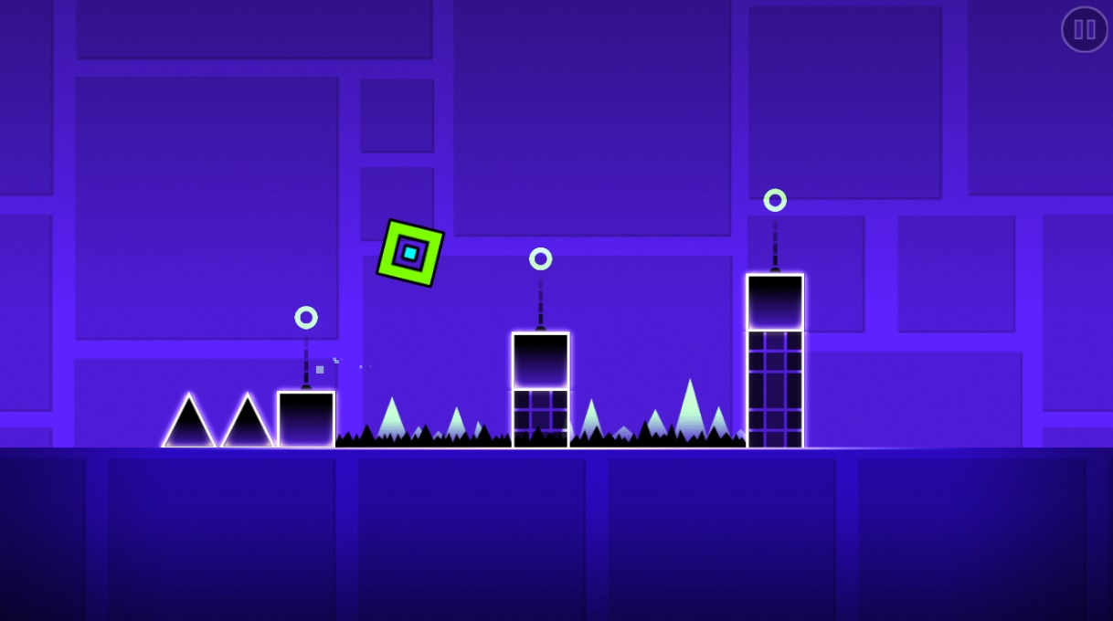

Geometry Dash is a game, in simple terms, where you go through an obstacle course with only the ability to jump with the goal of reaching the end. There are different forms such as a part of the course where the movement becomes like jetpack joyride, or the screen becomes reversed. Once you finish the course there are more courses that come after. The features I plan to integrate are the different forms but I will integrate them as events that occur at certain points instead. Features I don’t plan to integrate are giving the game an ending/finish as that removes the replay ability and goal to keep improving from my solution.

Essential Features:

- A jump movement as this is how you control the character and allows you to play the game. (Benefits Family and Friends as it makes it more casual and easier)

- A score system as this gives the player motivation to play and allows people to keep track of their progress and compete with others. (Benefits Clients more but others still benefited)

- Different obstacles as this gives a challenge to the game like how jetpack joyride does it allowing replay ability factors and creating a higher skill ceiling. (Benefits Clients more as it gives them the chance to show their skills)

- Events not only encourage the challenge aspect of the game but it also makes the game more enjoyable as anything can happen. (Benefits Clients as it tests how they perform under certain circumstances, and Benefits Friends as it makes casual play a lot more fun and

goofy)

The reason why such specific features are essential, even though most games these features wouldn't be considered “essential” is because the game is made to be challenging and difficult through gameplay mechanics instead of control of your character. This allows the game to be played by beginners and hardcore gamers.

Limitations:

- There will be no cosmetics/coin system as cosmetics have a long history in games affecting gameplay, giving unfair advantages/ disadvantages. Therefore, to make it fair and competitive cosmetics will not be included. No coin system as coins can make the screen a lot busier than it already is making it tiring to play.

- No exact control of the character removing skill aspects to the game but this is done to make the game beginner friendly and creates a new atmosphere/experience for gamers from their usual games.

- No ending to the game allowing an infinite score and infinite replay ability. Allowing competitive play to be extended. However, it does remove the sense of accomplishment from a lot of players and no goal to reach.

- No appealing animation/graphics as smooth gameplay is prioritised over looks/graphics. This is done to allow the game to be fluent and allows it to run on a lot of systems easier without frame drops.

**Requirements:**

Minimum Software/Hardware:

OS: Any Windows/Linux/Mac Operating Systems.

Processor: 2.0+ GHz

Memory: 512 MB RAM

Graphics: OpenGL 2.0 Support

Storage: 100 MB available

Peripherals: A mouse(with left click) or keyboard(with space) and a monitor

Others: Must have pygame installed on the computer to run and an application to run pygame files.

Design:

|  |  |
| --- | --- |
| **Requirement** | **Explanation** |
| Simple Game Window | A window where all of the games sprites/graphics are drawn (what the user sees when they open the game) |
| Background | A background which creates scenery and gives the window a new look (makes it appealing to the user) |
| Scrolling Floor | A floor located below the background which scrolls backwards to give the user an illusion of movement |
| The Main Character | A main character which the character controls being drawn in and located around the middle left of the screen |
| Obstacles | Different obstacles which move differently for example, (one moves diagonally, one moves upwards etc) drawn onto the screen to show the user where they are |

Functionality:

|  |  |
| --- | --- |
| **Requirement** | **Explanation** |
| Start Button | A visual button that appears when the game window is launched that when pressed starts the game |
| Jump | A button on a peripheral like space or left click that makes the character jump up a little bit |
| Score System | +1 point for surviving every 5 seconds with a score display on top of the screen that shows the user their score |
| Hitboxes | Hitboxes/Rectangles drawn around the character/obstacles to give them a collide feature to calculate when the user loses |
| Obstacle Generation | Random generation of obstacles on where they spawn on the screen to which obstacle spawns |
| Replay Button | A visual button on the death screen that has the function to restart the game code or exit the game window |
| Events | An occurrence that happens when reaching a score milestone that changes how the user plays (Faster obstacles etc) |

**Success Criteria:**

|  |  |
| --- | --- |
| **Criteria** | **Evidence** |
| A Window named “Flappy Duck” which opens when the game is run | Screenshot of the window and code |
| A Starting Menu that allows the user to press play and start the game or press Exit and leave the game | Screenshot of window and code |
| Set a background with a scrolling floor below it | Screenshot of the background and floor and code for scrolling floor |
| Draw a Duck sprite on the screen in the middle left and setup a hitbox/rectangle around it | Screenshot of the duck on the screen and code of the drawn rectangle around the sprite |
| Setup movement: A jump button which when pressed makes the duck sprite go up fluently and make the duck constantly go down when jump button is not pressed | Screenshot of the code that shows the user inputs to effect it has. |
| Draw obstacles and set up hitboxes/rectangles around it. Define its movement as well (Minimum 3) | Screenshot of the obstacle sprites on the window and show code of hitboxes and movement |
| Generate obstacles randomly on the right side of the screen above the floor, random area and random obstacle | Screenshot code that shows how they are generated randomly |
| Create a way for the duck to die resulting in the user losing | Screenshot code of the collision of main character and obstacles resulting in a loss |
| Replay button on the death menu which restarts the code and allows the user to go again without reopening and a button to go to the main menu | Screenshot of the replay button and show code of its result. |
| Add a score system which is displayed on the top of the screen which increments +1 score every 5 seconds the user survives after pressing the start/replay button | Screenshot the counter on the top and the code that adds +1 every 5 seconds |
| Add random events (Minimum 2) Which when reaching a certain score take effect | Screenshot the code |

**DESIGN**

**Decomposition Diagram**

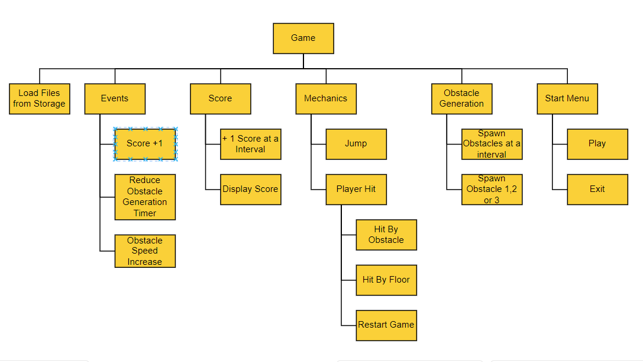

Game:

The “Game” Decomposition diagram breaks down my solutions coding side and features from the program itself instead of sources from outside it. Breaking down the games features into smaller problems will help me while developing the program as I can see every feature I need to implement into the game and will help my testing phase as if I focus on coding each smaller problem one at a time instead of coding multiple at the same time it will be easier to debug the problems I run into while coding my solution. For example, when I am developing the mechanic for the player to jump I will focus on all the features that come with a jump such as moving the sprite up and gravity to make the bird come down so when the player jumps he will not just be stuck in the jump therefore when developing and my jump moves the player down instead I will know it has to do with the smaller subproblem instead of the whole of the problem. Overall, breaking down my solution into smaller subsets of problems will aid in my development as it will help me understand my own program and make a solution fitting for my stakeholders requirements/desires

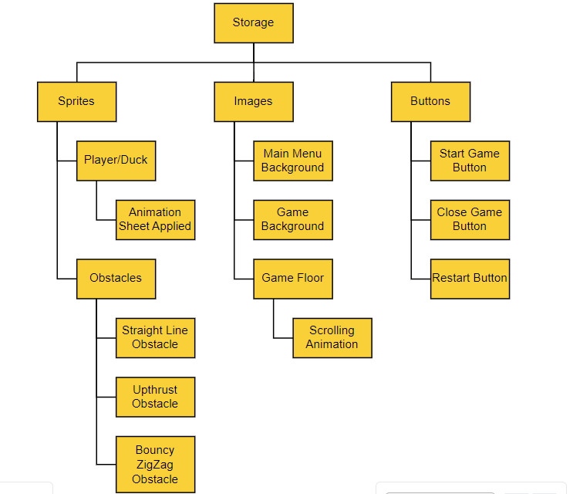

Storage:

The “Storage” Decomposition diagram breaks my solution into files needed for development. This allows me to identify a certain theme/design for my project fitting to my game and stakeholders needs. These files will change how accessible the game is, how the game feels and how the user feels while using my solution. Therefore, for my solution, the goal is to make the game accessible so I will need images that are understandable by a broad audience when interpreted, a simplistic colour theme which makes the user feel at ease and a plain background/floor which is not too flashy while making the player and obstacles stand out to the user as the game is meant to be a challenge and for a challenging game the core parts need to be highlighted to make it as much of a competitive environment as possible. Overall, breaking down my storage side of the game into smaller subsets will help me prepare for development and decide what to highlight.

**Flowchart**

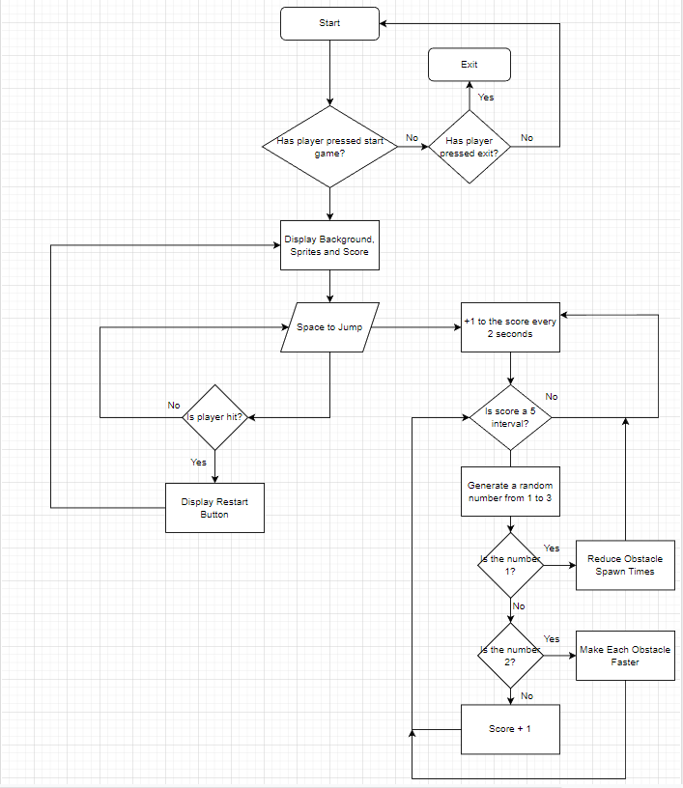

Structure Of My Solution:

The structure of my solution follows an iterative structure as the core premise of my game is a simplistic game which doesn’t have a lot to it but offers replay ability. Therefore a lot of my game relies on loops and searching/waiting for conditions to be met to take action and display an event. The basic loop my game follows is start,play,lose,restart,play,lose,restart… and carries on

**Basic Screen Design**

Start Screen:

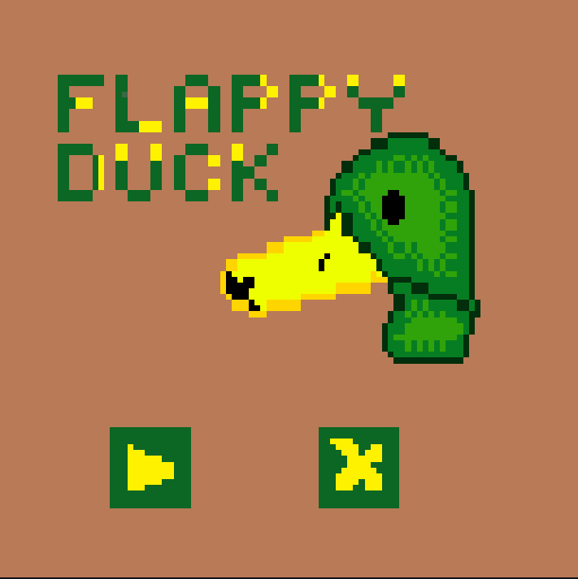

This is going to be the first screen the user sees when he launches the program. It gives the user 2 options through the use of buttons which lead the user to another screen of the game. The design is simplistic and easy to understand while using buttons which are universal and understandable no matter what language the user speaks. The first button moves the user to the game screen where the user will be able to use the program for its intended purpose while the other button gives the user a easy accessible way to leave the game when they want. Overall, this start screen is important for my solution as it allows any user to use it and gives an introduction to the game from its simplistic and beautiful look.

Game Screen:

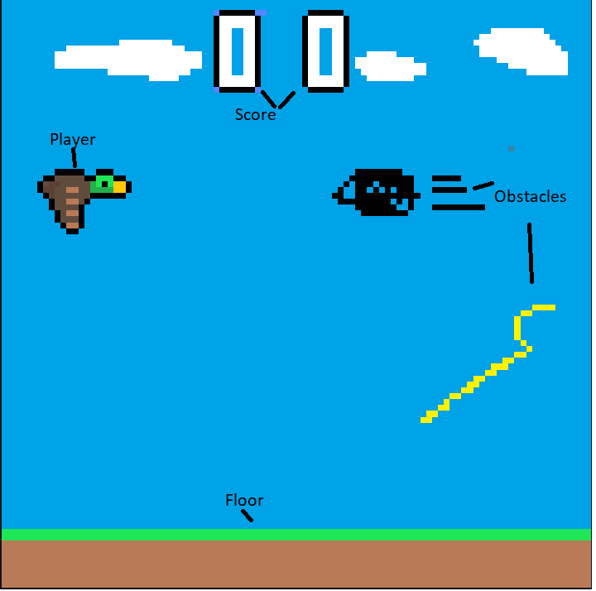

This is the game screen, the screen which is entered through pressing the play button/first button in the start menu. It essentially is the game itself therefore a lot will be happening on this screen but the goal of my project is too not make it feel too cramped and busy but relaxing and minimal. The “floor” will be at the bottom of the screen which the user cannot touch or they will lose and its important that it takes the right amount of space as if its too small it will be hard to notice and if its too big it will take away from the experience for the user. The player and obstacles will contrast from everything else around it so they will be very noticeable for the user but minimalistic as well as my stakeholders are looking for a game that feels smooth to play. The score counter will be at the top of the screen as I’m following the conventional score counter from other projects such as flappy bird as that’s what my stakeholders and users are looking for from this game.

Death Screen

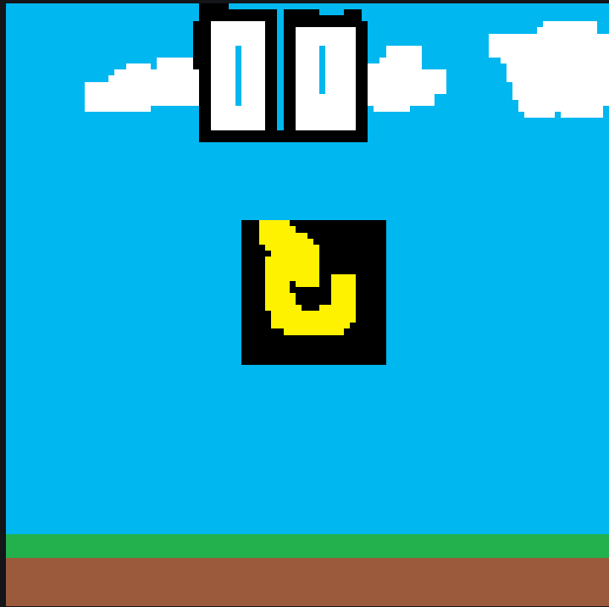

When the user loses, the screen he enters is identical to the game screen with the score displaying in the same spot. However, in the middle of the screen a big button will appear that when the user clicks it will reset the game. This is done to keep the game simplistic and allow the user to go straight back into the game without changing screens too much. However, there is only a replay button but no exit button meaning the user will have to manually leave the game which is an improvement I could make in the future to make the game feel more fluent and accessible

**Algorithms**

Start Screen:

if start_button == True: #Checks If the start button was clicked

function game #This will launch the main game loop and go to the game screen

if exit_button == True: #Checks if the exit button was clicked

exit #This will just close the program

This gives the start screen usability and allows the user to interact with the GUI to cause actions to take place such as the game starting or the program closing.

Loading Assets:

Pygame.image.load(“Background.png”) #Loads the background ready to use

X = 0

While X < 6 #Loop

Pygame.image.load(“Duck{X}”) # Animates the duck sprite

X + 1

If X == 5:

X = 0

This gets the assets ready to be used and creates the animation for the duck which allows the user to see the duck replicate real movement

Movement:

If mouseClicked == True: #Checks for mouse input

Duck.y -= 10 # moves the duck up

If pygame.key.getpressed(“A”): #Checks for input of “W”

Duck.x -= 5 #moves the duck to the left

This shows the movement options for the user and what movement occurs when the inputs are clicked by the user.

Score:

Score = 0

Time = Pygame.time.get_ticks() #Gets how many ticks happened since game ran

If Time = 5000: #If 5000 ticks happened (2 seconds)

Score += 1 #Adds 1 to the score value

Time -= 5000 #Sets the value back to 0

The score system for the game is different to usual games and relies on gathering on ticks and how long the games been going on for to calculate the score

Collision:

If duck.x or duck.y == obstacle.x or obstacle.y #If the duck/player has the same coordinates as one of the obstacles

gameEnd = True

If duck.x or duck.y >= (number for the coordinate of the floor): #Checks if the duck/player is in the floor or not

gameEnd = True

The duck/player colliding with an obstacle or the floor is the loss condition for my game therefore it is important to check if the duck actually collides with the obstacles or floor by always finding out where the duck/obstacles with their values always changing and with the floor being a constant value.

Events:

If score %5 == 0:

Random = Random.randint(1,3)

If Random == 1:

Obstacle_timer -= 500

If Random == 2:

Obstacle_speed += 5

If Random == 3:

Score +=1

Events are apart of my game to spice it up and can change the course of the game and encourages the user to adapt to their current situation based on the event the user has been given. They scale the longer the game lasts adding challenge and competitiveness to the game

Restart:

If gameEnd == True:

gameEnd = False

Obstacle_speed = (original value)

Score = 0

Obstacle_Timer = (original value)

Duck.y = (original spawn value)

Duck.x = (original spawn value)

The point of the restart function in my game is to set all my important variables to their original values so the user can start at the usual starting spawn with all values default meaning that every time the user presses play the game will be even and fair for everyone. This promotes competitiveness and fairness towards players.

Obstacle Generation:

Obstacle_timer = pygame.time.get_ticks() #Gets how many ticks till game started

If obstacle_timer == “1000” #Checks if 1 second passed

Choice = random.randint(1,3) # Choice becomes a random number from 1-3

If Chocie == 1:

Obstacle1() #Spawns obstacle 1 from a class

Obstacle_timer -= 1000

If Choice == 2:

Obstacle2() #Spawns obstacle 2 from a class

Obstacle_timer -= 1000

If Choice == 3:

Obstacle3() #Spawns obstacle 3 from a class

Obstacle_timer -= 1000

Obstacle generation is important to my game as randomness is an important feature in my game as what obstacle spawns and where it spawns all impacts the game and makes the user have to think on what to do next. It also matters how fast obstacles spawn as we do not want to make it too crowded to the point its impossible but enough to be challenging

Whole Solution:

My whole solution will be a game where when the user presses play from the start menu, the game will start and the user can interact with the duck by having to move it up as gravity will be implemented making the duck move down constantly and the player will have to balance it with jumping also allowing the user to change his height level to dodge obstacles and the user will also be able to move left and right to increase skill needed and gives the user more freedom while playing. Obstacle generation being random and events are added to make the game more challenging and encourage adaptation to new scenarios that you have no experienced before. With the game needing a loss condition, the collision point between the player and the obstacles and floor needs to be emphasised as it impacts the competitiveness of the game and changes the outcome of the game. The score is what separates players of different skill classes and gives players/users goals and it is calculated through time played and is what triggers events to happen. These algorithms form a complete solution as it covers all the bases of my game and create the game that the stakeholders are asking for meeting all of their requirements

**Usability**

Interface

The interface in my game is very simple and understandable, it allows the user to navigate it easily and knowledge beforehand is not needed to use the interface as it is beginner friendly and can be understood by anyone

Objective

The objective of my game is clear which allows the user to set their sights and create goals and they know what they need to do so they can use the program with no assistance needed

Visuals

The visuals in my game is suitable for anyone as it is very simplistic and minimalistic and allows the user to make choices without being overwhelmed by the visuals

Difficulty

My game is a beginner-friendly challenging game so the difficulty of the game itself is high, but the controls are very intuitive and easy and anyone can easily get used to it and play the game

**Key Data**

Key Variables:

|  |  |  |
| --- | --- | --- |
| Variable Name | Data Type | Description |
| window_width | integer | This is the width resolution of the game window |
| window_height | integer | This is the height resolution of the game window |
| fps | integer | How much frames per second the game is ran with |
| scrolling_speed | integer | This is how fast the floor will scroll to emulate “movement” |
| birdStart | boolean | This determines if the bird has started moving yet |
| gameEnd | boolean | This determines if the game has ended or not |
| obstacle_timer | integer | This determines how fast the obstacles spawn from one another |
| plane_speed | integer | This is how fast the obstacle “plane” will go |
| shark_speed | integer | This is how fast the obstacle “shark” will go |
| ball_speed_x | integer | This is how fast the balls x value will go |
| ball_speed_y | integer | This is how fast the balls y value will go |
| score | integer | This holds the value of the current score |
| score_timer | integer | This is the time taken to increase the value of score |

Classes:

Button Class:

The button class is a simple class that when initialised for each object in the class it sets up a image associated to it, it setups the top left coordinates which allow it to setup a rectangle around the button which will allow the button class to be interacted with by the user. It also is initialised with a variable that checks if the button was clicked or not. After initialised the button class contains a function called draw which when called draws the interactable button onto the screen into the coordinates it was called in. However, the draw function also checks if the button is clicked and if it is it returns a variable with the value True which allows actions to take place if the button itself was interacted with

Duck Class:

The duck class is the core of my code as it’s the class that contains all the physics/mechanics and data of the player. When initialised it sets up the entire animation process by loading up the files from storage at different intervals and looping it to create an infinite animation that emulates the feel of the duck flying. The initialisation of the duck class also creates a hitbox for the player. The class contains a function called update which handles all the processes related to the duck such as when to change the animation for the duck, makes sure the duck cannot go under the floor or over the roof, the gravity of the duck so the duck is always going down unless the user enters the input required for the jump which then in that case the duck will go up and finally it also contains the movement of leftwards and rightwards. Overall, the duck class contains everything associated to the player.

Obstacle Classes:

There are 3 different obstacle classes with each having the same initialisation of setting up the hitbox of the obstacles, however with a different update function as each of the obstacles have different movement. For example, obstacle 1s class update function will just change how fast the obstacle will go in the x axis while obstacles 2 class update function will just change how fast the obstacle will go in the y axis.

**Testing**

|  |  |  |
| --- | --- | --- |
| Test | Inputs | Outcome |
| Main Menu |  | A window with the main menu loaded in with 2 buttons which when clicked an action takes place |
| Play Game | Left Click | Goes from main menu to the game screen |
| Close Game | Left Click | The program closes |
| Jump | Left Click | The duck goes in an upwards motion |
| Left/Right Movement | A,D | The duck goes left/right depending on what input is registered |
| Collisions |  | If the user gets hit by an obstacle or goes to the floor the game will end |
| Score |  | The score will increase at intervals of 5 seconds |
| Obstacle Generation |  | The obstacles will spawn at certain intervals, random obstacle random location |
| Events |  | Events will trigger when score is an interval of 5 |

**Development**

**Modules:**

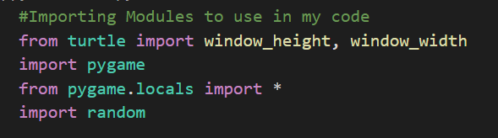

The turtle import has no relevance in my code it just appears every time I run my code but I don’t use turtle in my solution

Pygame is my main module that I am using as my whole game runs on pygame functions and alongside python is the main coding language I am using

Random will be needed to just generate a random number every time from a list and will be used to just allow a “random” generation in my solution

**ITERATION 1**:

The goal of this iteration is to make an interface with a functioning starting menu which allows the user to either start the game or close the game with 2 simple buttons with universal symbols so there is no language barrier. When the user presses play I want the game to display the sprites of the duck and a PNG as a background with a moving floor to simulate the feeling of the duck actually flying throughout the air. I also want the duck to be animated to further immerse the user and create the environment of the duck moving when it isn’t in reality.

To do this I will follow my success criteria from SC1 to SC4 and this entails my goal to reach for this current iteration as I just want to create an environment for the user and have all my outside sources such as the background png and the duck sprite etc to be displayed and usable with the other outside sources to be loaded in and ready to be used.

SC1:

The first part of the game is to make a functional window that appears to the user when they run the game that is labelled “Flappy Duck.” This is important to the solution as this window will be where the game is run, displayed, and used and will be the base for my solution.

The code below is what I wrote to create this window and at its current state it has no functionality except just appearing on the screen which is progress but nothing that will help the users when using this solution as it does not match their needs/requirements

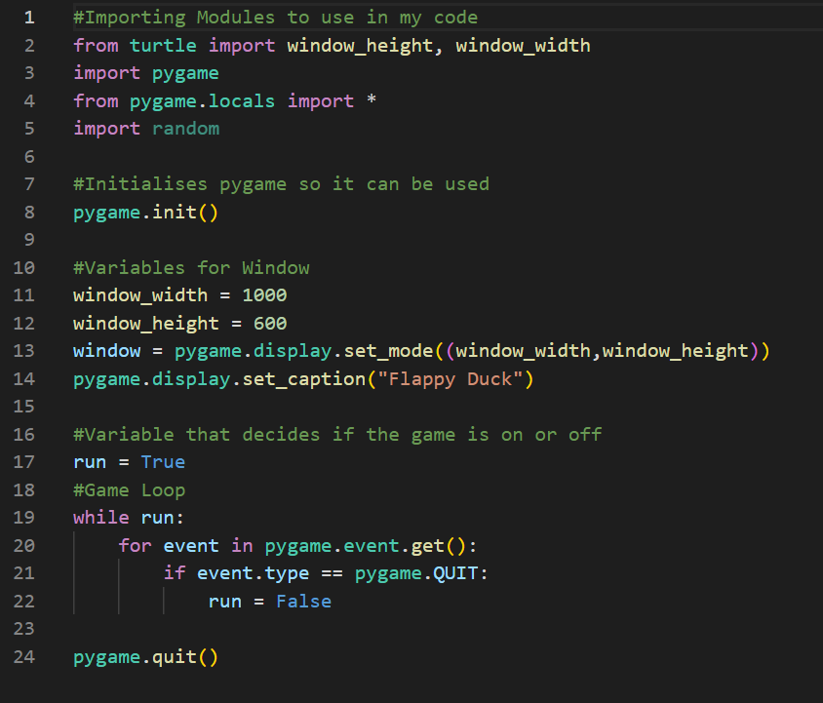

This is what the users sees:

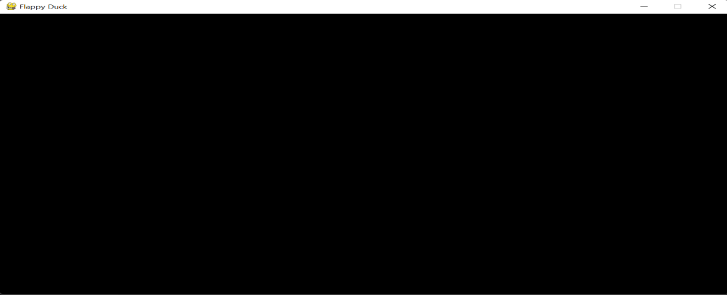

So far, I have encountered no errors coding my solution and to do my next stage of development I need to create files for my game to use such as the background, the duck etc therefore to continue, I will need to get my outside files now following my decomposition graph. I found my background and floor from the internet which I had to adjust (will explain later why), got my duck sprite with its animation sheet from the opengameart website and I drew my starting menu and buttons which I will use in later parts of the code. Once I made all of these, I had to load them into my code so I can use them in my solution

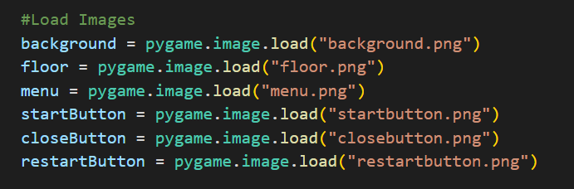

But before I continued to SC2, I also decided to add a cap to the frames per second to improve the usability of the solution for the user and to improve the feel of my solution/make it more smooth. To do this I first implemented 2 new variables to my code

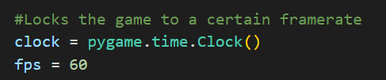

The fps variable is the frames per second I want my game to be at while the clock variable is a pygame function I need to set the limit on the fps

Then to apply this cap, I went to the main loop of my game and added this statement



SC1 Recap:

Testing:

|  |  |
| --- | --- |
| **Test For** | **Result** |
| Window opens when run | Success |
| Window named “Flappy Duck” | Success |

Extras:

Loaded up all outside files for future use and added fps cap for usability purposes.

SC2:

The next part of my solution is to create a starting menu which appears as soon as the user launches the program, this starting menu will contain a fitting introductory background with 2 buttons; the starting button which when the user clicks it, it will launch the main game, the other button being a simple exit button when clicked, it will close the program. The starting button is important as it is necessary for the user to enter the solution they want while the exit button is a feature of convenience and allows for broader audience to understand how to leave the game.

To start I created a new function called GameMenu() and added code the put up the menu, then I put added the function to my main game loop

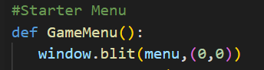

However, this did not work for me, nothing changed and it just loaded up a black window. Therefore I decided to make a big change and make a new game loop in my GameMenu() function and run the function in the main code separate from my game. To do this I had to make my main game loop into a function as well and I called it Game()

Game Menu Changes:

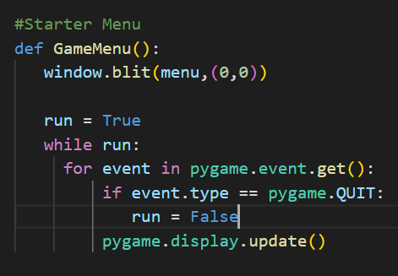

Other changes:

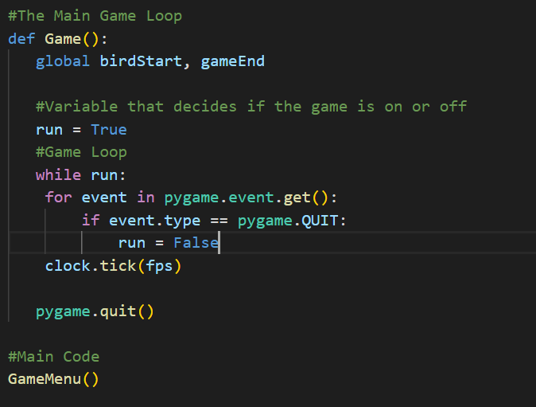

After I made these changes, it started working the way I intended. When the user runs the code a window opens up with the background of my starting menu loaded up.

What the user sees:

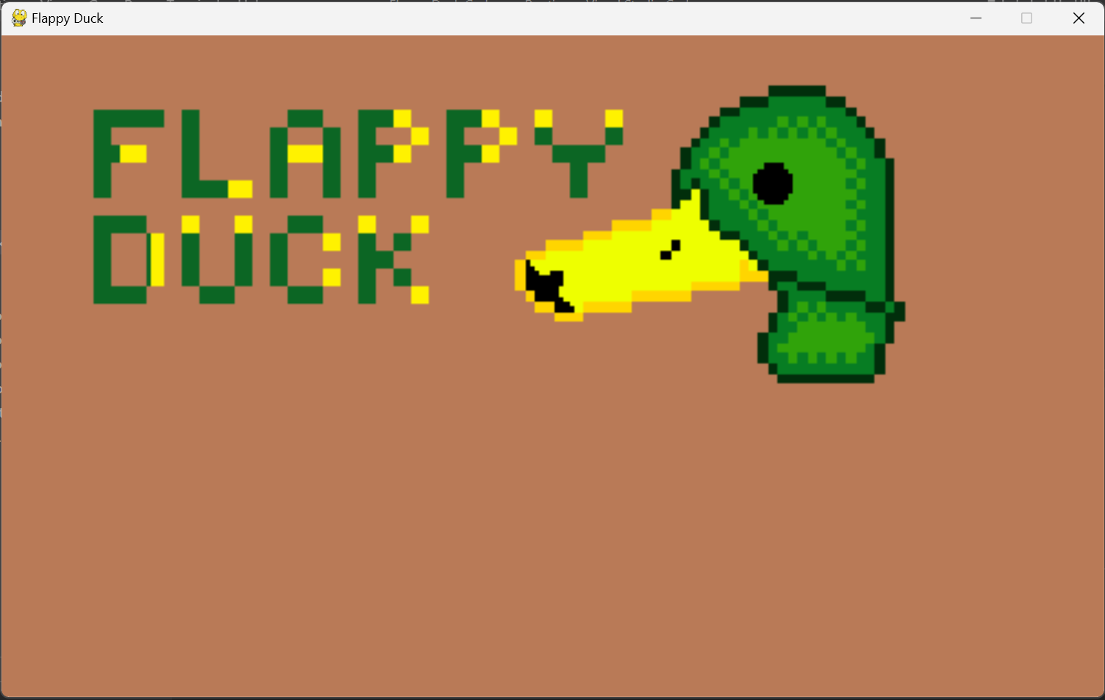

The next steps I have to take is to add the buttons so the user can actually interact with the solution now. To do this I am planning to add a button class which will help me easily setup a button anytime I want in my solution without having redundant code. Therefore, I created a button class and setup an initialising function

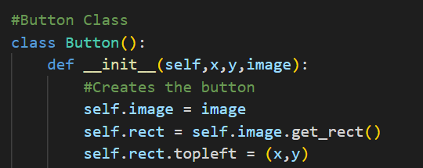

At this point, I didn’t know how to continue and how to make a button that works when its coordinates are clicked and to give it different functions depending on which button is clicked so I searched up online how to make buttons on pygame and took features from multiple different articles online and ended up creating my button class like that. In the end, this is the outcome of my research

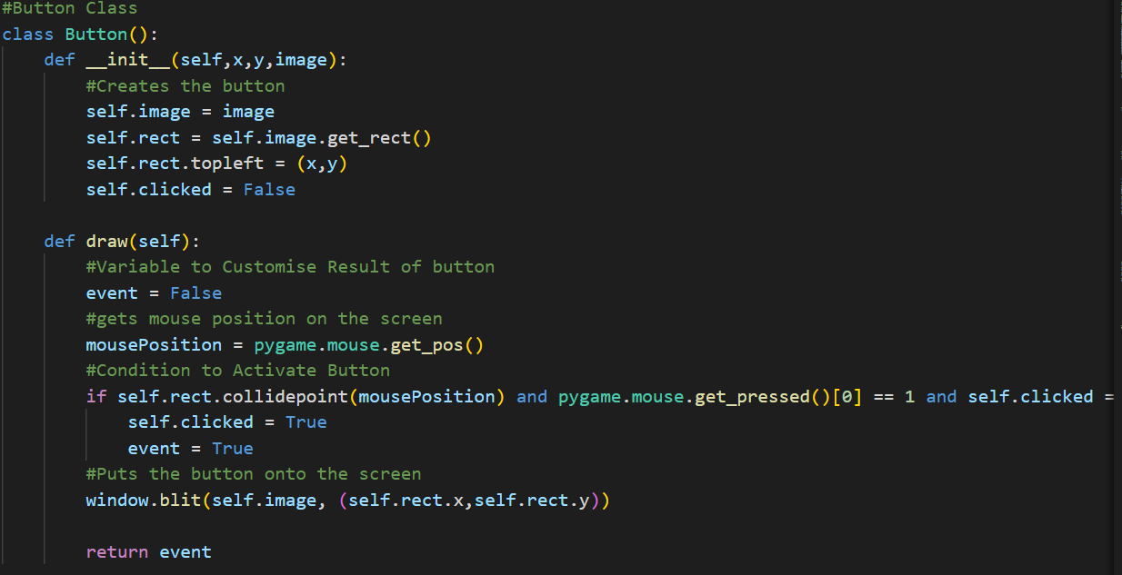

Now it was time to create the buttons and give them functionality, to do this I will need to create a starting button object and closing button object.

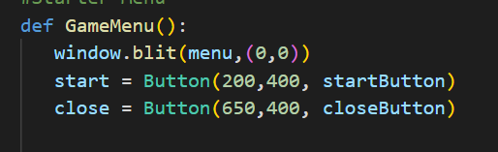

With the buttons initialised, I needed to output them onto the screen, thus I had to call the object and use its function

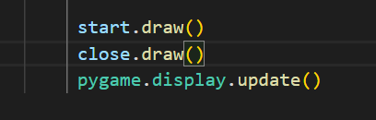

After all these additions, when the user runs the code, this is the outcome:

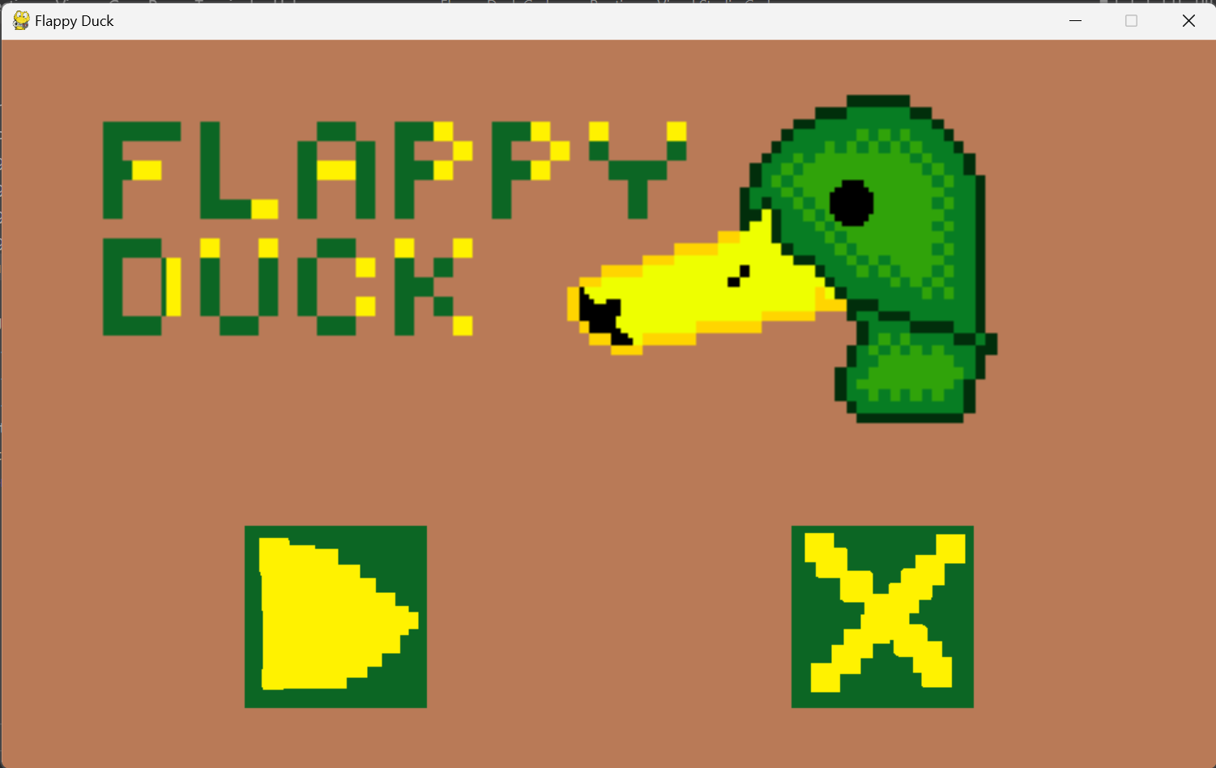

|  |  |
| --- | --- |
| **Test For:** | **Result:** |
| Display Buttons | Success |
| Start Button starts game | Fail |
| Close button exits the solution | Fail |

I realised that I did not give the buttons any functionality, to fix this error I noticed that in the button class I created it returns a Boolean value, hence if I wanted an event to happen when I clicked the button all I had to do was create an IF statement and if the value of the button is “True” then I create the intended result of the button being pressed.

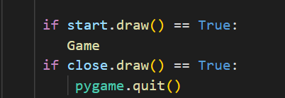

|  |  |
| --- | --- |
| **Test For:** | **Result:** |
| Display Buttons | Success |
| Start Button starts game | Fail |
| Close button exits the solution | Success |

My assumption is that the start button doesn’t start the game yet since there is no game coded yet therefore, I finished my goals for SC2

SC2 Recap:

Testing

|  |  |
| --- | --- |
| **Test For:** | **Result:** |
| Display Buttons | Success |
| Start Button starts game | Fail |
| Close button exits the solution | Success |

Extras:

I have made no extra additions during SC2 and only followed to complete the goal of SC2 to move onto SC3

SC3:

The objective for this part of my code is to create the environment the user is playing in, display the background for around 3 quarters of the screen and then for the other quarter to be a “floor” which is another png file but with an effect of scrolling by moving the png file to the left. Another goal I have for this segment is to fix the issue of the start game button in the starting menu not working as now I will have a game for it to launch into as the display will be changed.

I have decided to create a draw() function which will hold all the variables that will be loaded into my main game. I have done it like this so it will be easier to debug if errors start occurring related to objects not appearing onto the screen. So far in that function I have added code to display the background png and the floor png onto the screen

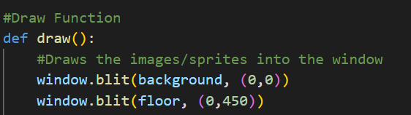

I have called the draw function in my game function so it can take effect when the game is running.

The start button was not working so in my main code instead of calling my GameMenu function I called my Game function and this was the result:

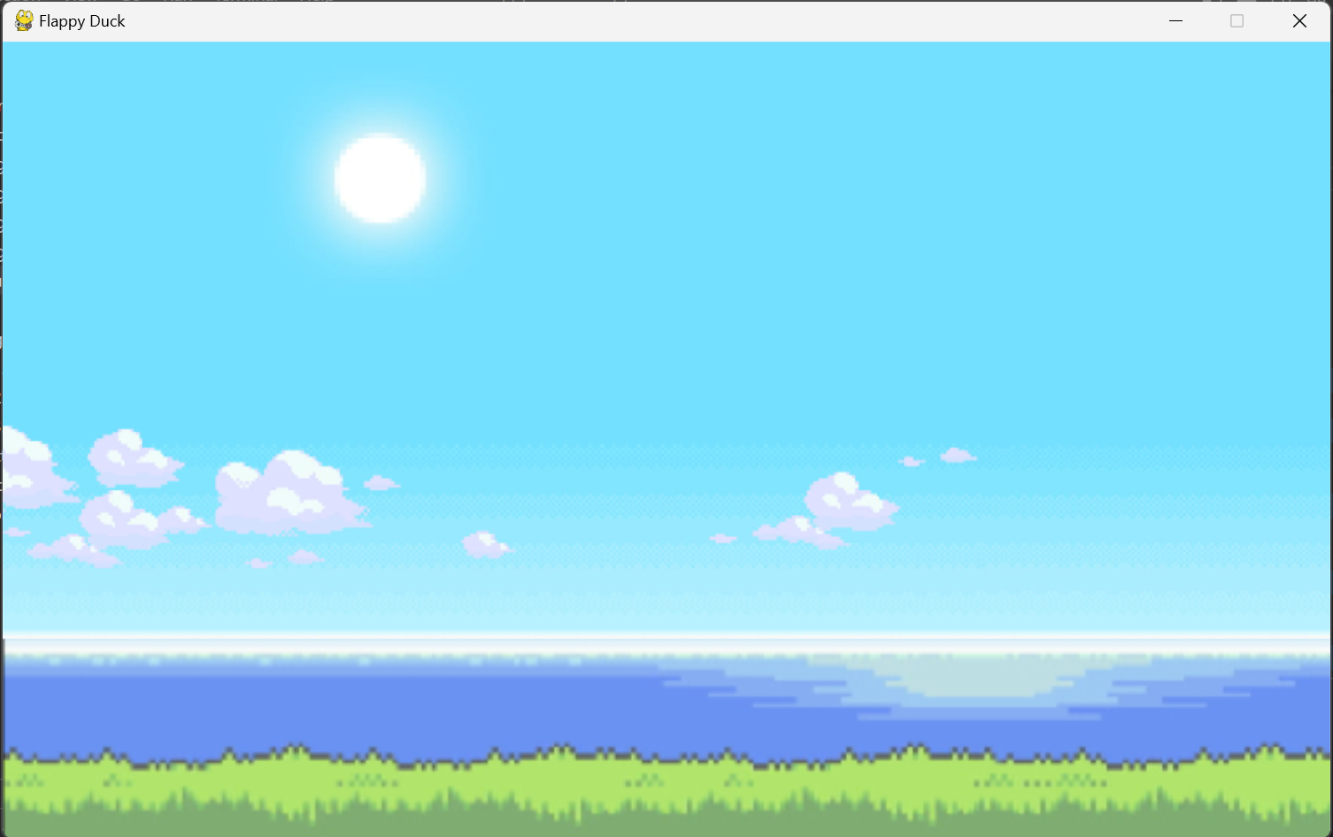

|  |  |
| --- | --- |
| **Testing For:** | **Result:** |
| Background Loaded | Success |
| Floor Loaded | Success |
| Scrolling Floor | Fail |
| Start Button launches game | Fail |

My next steps were to fix the start button launching the game as this has proven it was not the fact that I had no game to launch but an error in the GameMenu function. After debugging, I have finally noticed the error, it was a simple syntax error made by me:

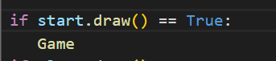

As its not calling the game function as I just wrote “Game”, to fix this I changed it to Game():

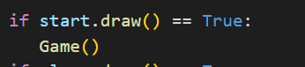

|  |  |
| --- | --- |
| **Testing For:** | **Result:** |
| Background Loaded | Success |
| Floor Loaded | Success |
| Scrolling Floor | Fail |
| Start Button launches game | Success |

Now that I have managed to fix an issue I had from before, I can continue with the current objective of creating a scrolling floor. To do this I will have to create 2 new variables:

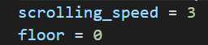

This variable will determine how fast the floor speeds, the lower the value the slower it scrolls while the larger the value the faster it scrolls. To use it in my draw function I had to make the variable global

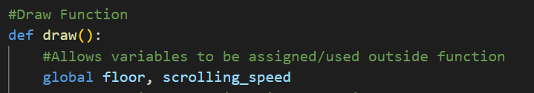

I realised at this point I made a huge error and the variable name floor was already taken for the variable that has the floor png loaded therefore I had to change it to scrolling_floor for the variable that will hold the x value of the floor. This means that I have also updated in the part where I blit my png of the floor from “0” to “scrolling_floor”. With all of this done I am finally ready to create a scrolling animation on the floor

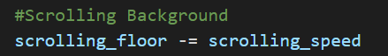

Result of the code:

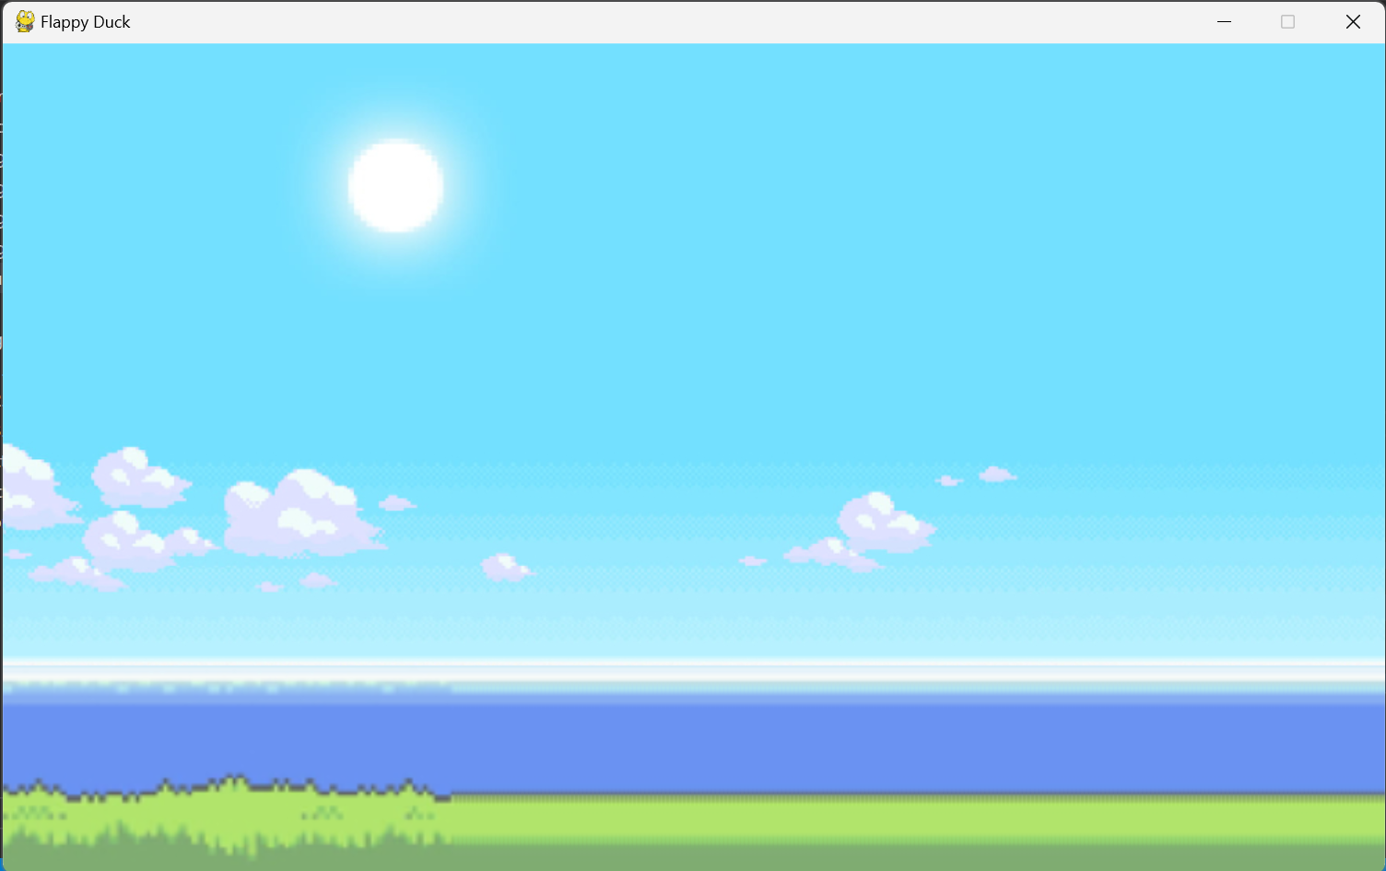

This is not the intended result I wanted as it does scroll but it loses its texture. To fix this I planned to implement a loop for when the floor reaches a certain value it will reset to the start of the cycle of the floor.

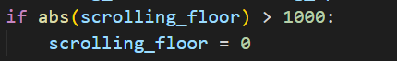

This did not work as the floor still went blurry but after the whole floor turned blurry it turned back to normal and kept the cycle going. The solution I applied to this problem is to change the dimensions of my outside file of the floor and double its width so it should scroll until the end of the png texture and start from the start of the png creating an infinite loop of scrolling.

After changing the dimensions of my floor png file it worked as I expected meaning I have finished my goals for SC3.

SC3 Recap:

Testing

|  |  |
| --- | --- |
| **Testing For:** | **Result:** |
| Background Loaded | Success |
| Floor Loaded | Success |
| Scrolling Floor | Success |
| Start Button launches game | Success |

Extras:

Changed the dimensions of my floor png file and added a draw function.

SC4:

The game is still lacking a very important part of it, the player/user himself. The goal of this segment is to display the player on the screen at its starting point(the point where the user spawns in at when the game first starts) and have the duck have an animation to emulate movement to further immerse the user, and to setup a hitbox around the duck. To do this I will create the duck through a class using a list of all its pngs and using a loop I will loop around these pngs to create an animation of the duck flying. Making it through a class will make it easy for me to be able to create a hitbox of the duck aswell as it’s the same as the buttons I made previously

I will use a pygame class as this adds many new features I can use in the class and it allows me to create sprite groups which will allow me to use to features of a pygame class in my draw function.

The first step is creating the class using a special pygame function which converts the class into a pygame class containing a lot of inbuilt features for my convenience

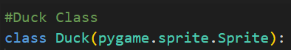

The next step is create an initialising function and an update function which allows the animations to take change during the game at certain intervals and keep looping.

Initialising function(Comments Explain It):

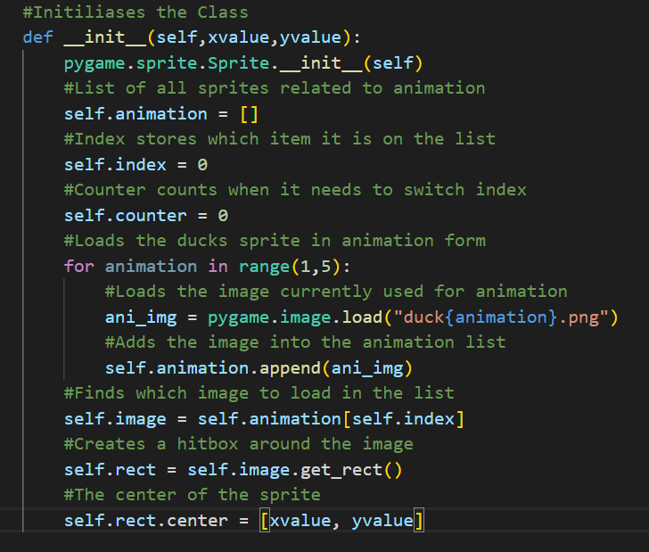

Update function(Comments Explain It):

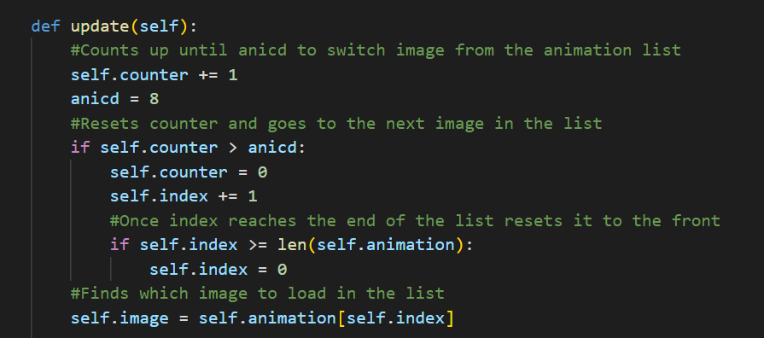

I could not test if this class works currently as I need to create an object off this class and add It into a sprite group then display it through my draw function. So I created a sprite group and added a duck object into it

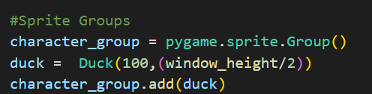

Then the final steps before testing was too add it into my draw function so it will display the duck in game

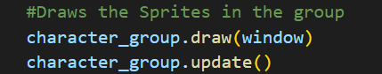

|  |  |
| --- | --- |
| **Testing For:** | **Results:** |
| Display Duck | Fail |
| Duck Animation | Fail |

The solution won’t even start due to syntax error. After debugging the solution I found out that the problem was in this loop

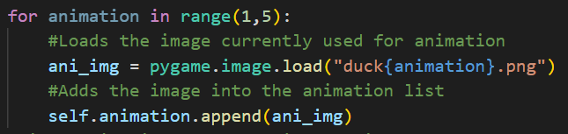

I found the syntax error after using VSC debugging tools and it was in this line



The correct syntax for this was:



|  |  |
| --- | --- |
| **Testing For:** | **Results:** |
| Display Duck | Success |
| Duck Animation | Success |

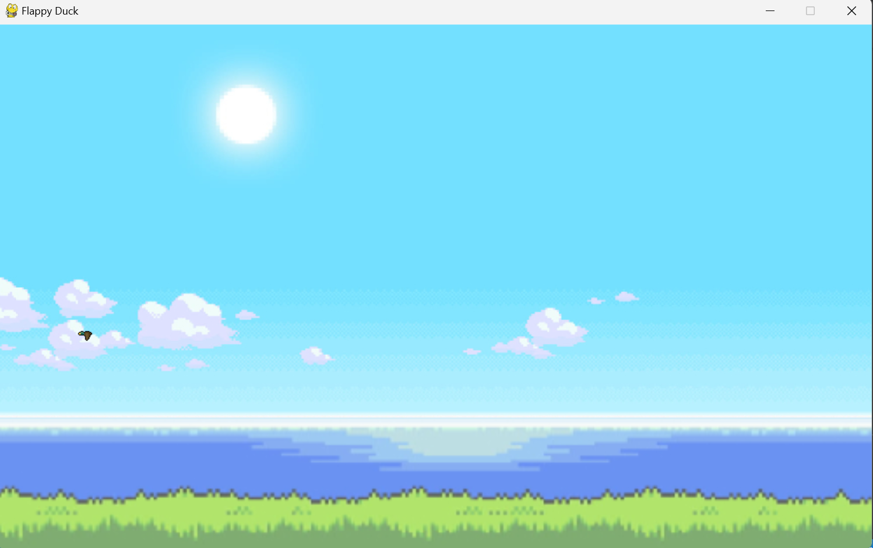

The display of the duck and animation was a success, however before I continue I will need to fix the error of the duck being displayed wrong. As the duck/player is facing the wrong way and is way too small. The solution to this is simple and it was a small addition to my Duck class

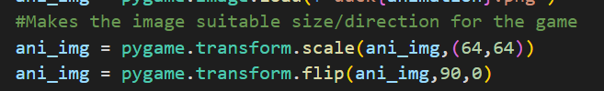

Result:

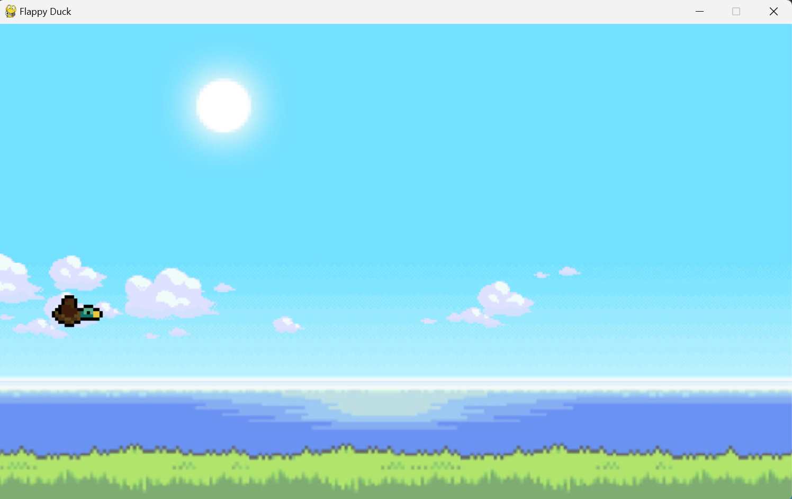

The final part of this segment is too test the players/ducks hitbox. To do this I will use code from my buttons which I will delete after testing. I will check if when the user clicks on the duck that it will output in console “WORKING!”

|  |  |
| --- | --- |
| **Testing For:** | **Results:** |
| Duck Hitbox | Success |

SC4 Recap:

Testing

|  |  |
| --- | --- |
| **Testing For:** | **Results:** |
| Display Duck | Success |
| Duck Animation | Success |
| Duck Hitbox | Success |

Extras:

No extras added to the code during SC4

**Iteration 1 Recap:**

Conclusion:

This concludes iteration 1, which the goal was to create a functional starting menu, load up all outside files, create the player and make an environment for the user. All of this was achieved in this iteration with some extras such as setting an FPS cap and changing outside files to make the game work. Overall, from a development standpoint, iteration 1 was a big success

Testing:

|  |  |
| --- | --- |
| **Test For** | **Result** |
| Window opens when run | Success |
| Window named “Flappy Duck” | Success |
| Display Buttons | Success |
| Start Button starts game | Fail -> Success |
| Close button exits the solution | Success |
| Background Loaded | Success |
| Floor Loaded | Success |
| Scrolling Floor | Success |
| Display Duck | Success |
| Duck Animation | Success |
| Duck Hitbox | Success |

Stakeholder Testing:

Friends: “It looks cool, we like the design, its clearly very well made but right now it’s a game without any gameplay”

Teachers: “Very impressive, the starting menu and the game design all link together and showcases a high-level skill of coding so far, can’t wait to see what’s to come”

Family: “Looks beautiful, will be a great game for sure”

Clients (that speak English): “The game so far is just what I expected, a well-made game and I’m expected the gameplay to be executed at the same level”

Clients (Foreign): “I like it, just what I was promised. A game that I can be immersed in and understand easily without having to search anything online. The gameplay must be magnificent if the creator wants to beat the hit game Flappy Bird”

Feedback:

* Not much I have to change with the design/theme of the game
* Gameplay is a big focus for my stakeholders so I need to be on point with it
* Follow my current plan as that’s the product my stakeholders want

**Iteration 2:**

The goal of this iteration is to make my solution playable; add a way to move the player, create obstacles, create a way to lose, random generation etc. This is the most important part to my solution as it’s the base that holds my solution together and determines how well made my solution is and if it meets the requirements/wants from all my stakeholders. Overall, the goal is to create a game which is simple and can be played by my stakeholders to receive feedback on how to make my program the best it could be.

To do this I will follow my success criteria from SC5 to SC8, these SC’s contain all the elements of my base game and will allow me to reach my goal and create a playable game which can be built upon in the future.

SC5

The first part of making a playable game is also the most important part. Establishing how the player moves, this will decide how the other parts of the game work as well. Therefore, my next step in my development is to create a way for the player to move. My goal is to give the player a lot of flexibility in his movement by allowing the duck to traverse all 4 directions it could. I also plan to make it accessible by giving different controls to move the duck, this will allow the user to use their preferred way of movement.

The first step I will take to reach this objective is to give the player horizontal movement. To do this I will add to the update function in the Duck class. I will have to use a pygame function of checking if a key was pressed by the user.

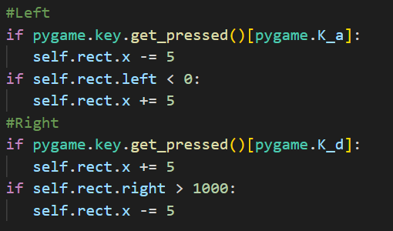

Result:

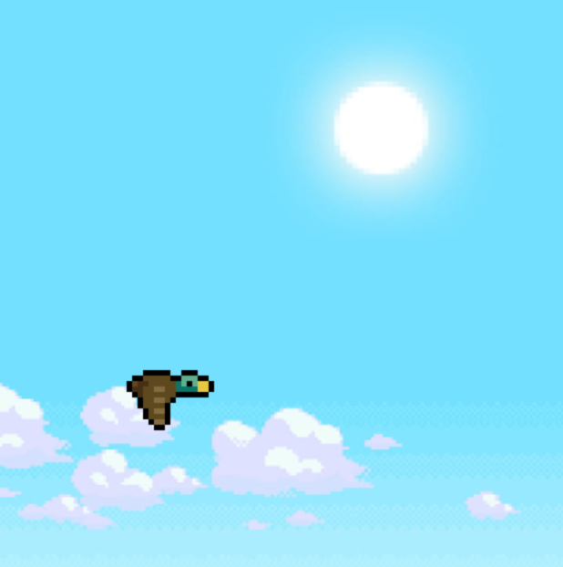 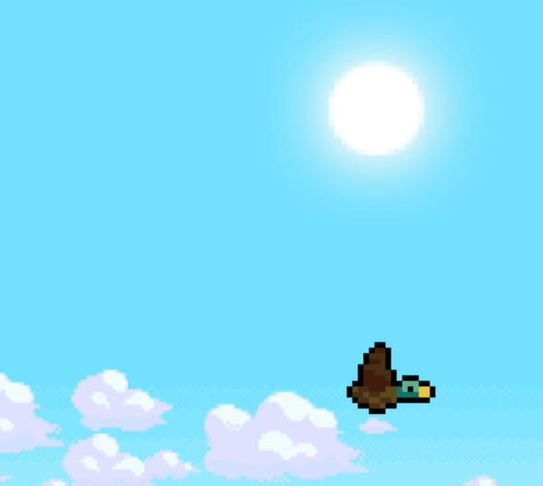

|  |  |
| --- | --- |
| **Testing For:** | **Result:** |
| Duck Horizontal Movement | Success |

To add extra accessibility, I will allow the user to also control the ducks horizontal with arrow keys. To do this I use the same exact code I used but changed the input required.

|  |  |
| --- | --- |
| **Testing For:** | **Result:** |
| Another Set of Inputs | Fail |

I will have to drop this feature from my game as every time I tried to add another set of inputs it would nullify the other as soon as I start using one when the game starts. For example, when I use “d” to move my duck right then the right arrow key wont work until I restart the game. I couldn’t find a solution to this problem so I will just continue developing other features and remove this

Now its time to work on the vertical movement, this requires me to make the duck be able to jump which will move the duck upwards, but to make it go back down after going up I will have to add gravity to the duck. This will also take care of the downwards direction movement for me. This means that adding gravity will take help me deal with the upwards and downwards motions. I will add gravity into my duck class as well and to do this I need to add a new variable.

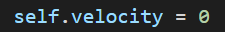

This velocity variable will determine how fast my duck is going up/down. Now I can add gravity.

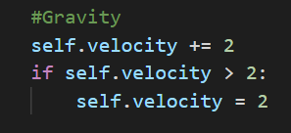

|  |  |
| --- | --- |
| **Testing For:** | **Results:** |
| Gravity | Success |

During testing, I faced an error of the duck just going below the floor and off the screen downwards. My solution to this was to add a condition which checks if the duck reached the floor and if it has, increase the y value of the duck by the velocity making it static

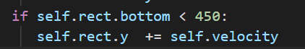

With gravity set up, I can implement a jump feature to add a way to the user to go upwards.

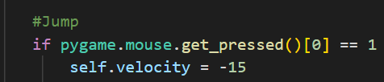

|  |  |
| --- | --- |
| **Testing For:** | **Results:** |
| Jump | Success |

The jump feature was successful. However, there is a lot of problems I’ve encountered while testing it. These problems include, the user can just hold the left click and then the duck will rapidly reach the top of the screen, the other problem being the duck just goes off the screen upwards

To fix the problem of holding left click I have to introduce a new variable to the duck class

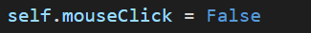

As this will allow me to add extra conditions for the jump to stop it from being held

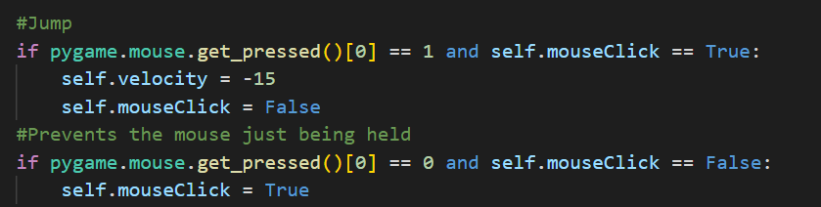

The second problem is also a quick fix, all I had to do was create a “roof”

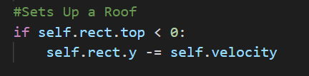

Before I am finished with the player movement, I would like to add a feature where gravity doesn’t take place until the player starts to reduce stress when pressing play. I have added a new variable to act as a condition

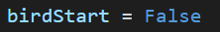

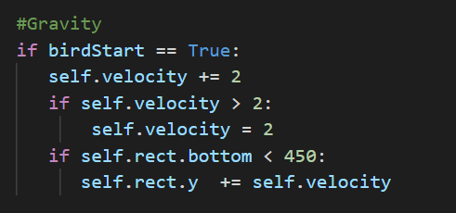

To make this work I had to add a way to activate the birdStart variable so I went into my Game function and added conditions to change the value of birdStart

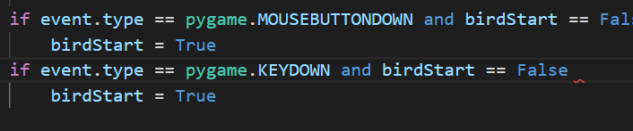

After further testing, all these patches have fixed the bugs in my solution and the players movement feels fluent/smooth as intended. With this I can continue developing further.

SC5 Recap

Testing

|  |  |
| --- | --- |
| **Testing For:** | **Result:** |
| Duck Horizontal Movement | Success |
| Another Set of Inputs | Fail |
| Gravity | Success |
| Jump | Success |

Extras:

Added a new variable which determines when the game starts which can be activated by the player moving the duck which I will use in the future as a condition.

SC6

The objective for this segment is to add obstacles, set up their hitboxes and give each of their obstacles their own movement. This part is very important as this is what determines how challenging the game will be and how immersive the experience will be for the user. I thought of creating the obstacles in a class system where there’s a parent class and I inherit for each obstacle however in the past when I was coding a project similar I ran into an error where each child class had the same png and I couldn’t change it so instead I will create a separate class for each obstacle to reach this goal

To start I will create the first obstacle and use it as a template for the others in the future but before I start making the others I will first finish the first obstacle by giving it its own movement.

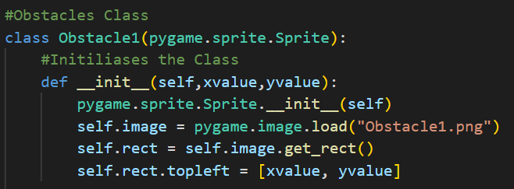

The first obstacle in my game is a plane, the movement I am planning to give this obstacle is just a straight horizontal movement. To do this I will need to create a update function in this class as it’s a pygame class and just move the objects x value by a certain speed. To set the speed I will add a variable as in the future I plan to be able to change the speed the longer the game goes on.



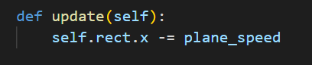

After this I created the same obstacle class twice:

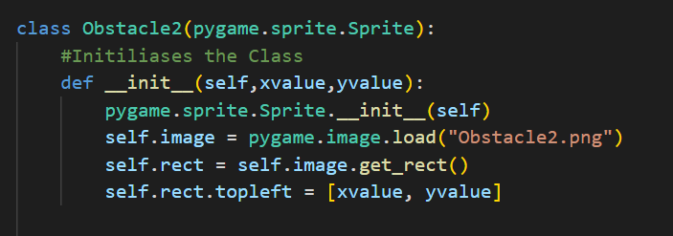

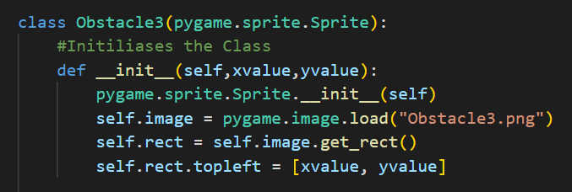

For my second obstacle I decided to make it a obstacle that goes upwards so I made the update function the following with a new variable as well:



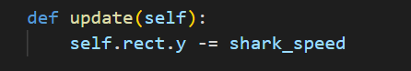

However, my third obstacle was a lot harder to create as I wanted an obstacle that would go in a zigzag button and bounce off the roof and floor like a ping pong ball. This will require 2 new variables as both the x value and y value will change

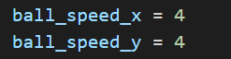

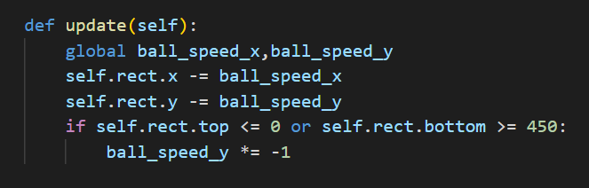

To display these classes I have to create an obstacle group like I did with the duck class.



And I also had to add extra code to the draw function to display these new sprites onto the game screen

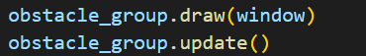

However, I faced a problem where I could not test these as I currently had no way to generate these obstacles therefore, I will have to test the movement and such later in my development and there’s not much testing and fixing I can do for this stage.

SC6 Recap

Testing

No testing happened in this SC

Extras:

No extras occurred

Overall, this success criteria cannot really be labelled as successful currently as I wrote a bunch of code which cannot even be tested to see if it works thus I will reference this SC in later development and conjure testing in for these additions in a future SC.

SC7

Now that I have the obstacles made and ready to be used, I have to actually generate these obstacles into the game. I plan on randomly generating the obstacles meaning that the obstacle generated will be chosen at random and it will be spawned randomly as well within the parameters given. To achieve this goal I will create a new function and call it in the game loop.

To execute my goal I will need to use new features I haven’t used before, to start I need to add new variables which will decide the interval of how fast the obstacles spawn.

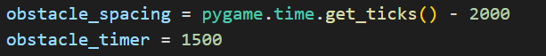

These 2 variables will help create a timer between obstacle spawning to create an infinite loop.

Firstly I must create the function and create global variables so they can be used from outside the function

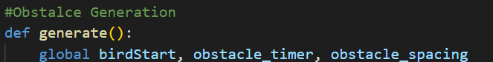

In the function I also have to create 2 variables, one variable to check how many ticks the game has been running for and one variable to choose a random number between 1 and 3 since I have 3 obstacles in my game

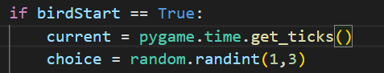

For my first obstacle generation, this is how I done it:

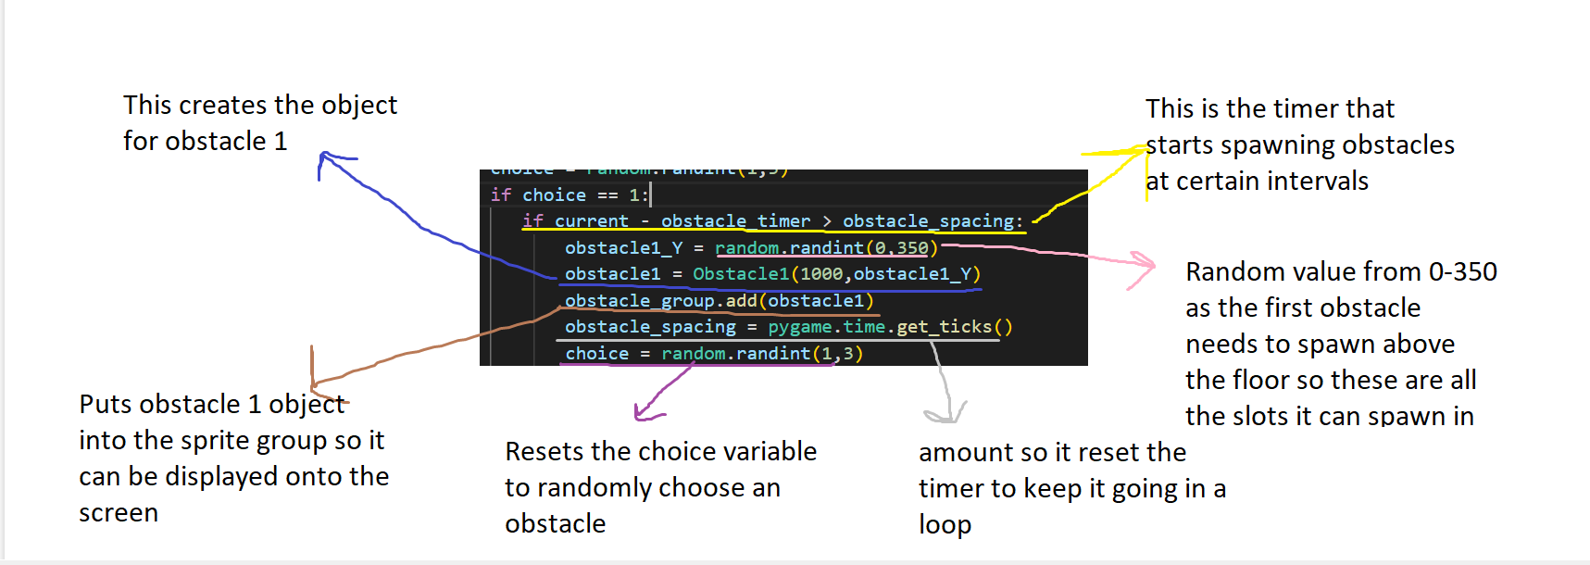

For testing purposes, I have changed the choice variable to:

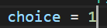

I will also include testing from SC6 in this current testing table as its generating an obstacle from SC6 which I created.

|  |  |
| --- | --- |
| **Testing For:** | **Results:** |
| Display Obstacle 1 (SC6) | Success |
| Obstacle 1 Correct Movement (SC6) | Success |
| Interval Generation (SC7) | Success |
| Random Axis Generation (SC7) | Success |

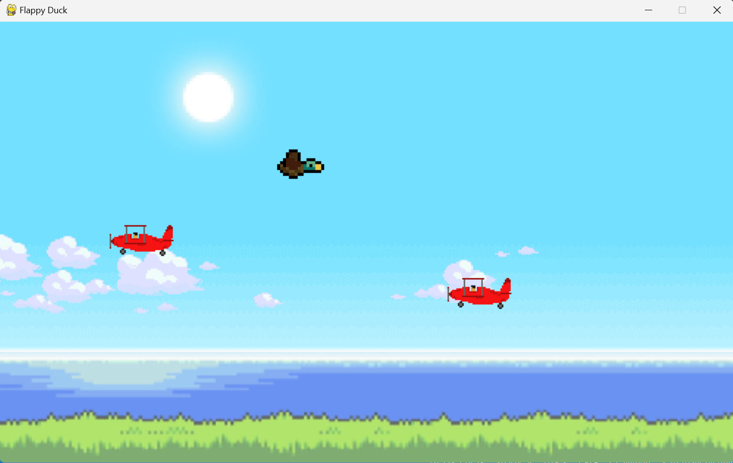

For my second obstacle I did a very similar process, however, I had to change some integers and variable names to fit this current obstacle

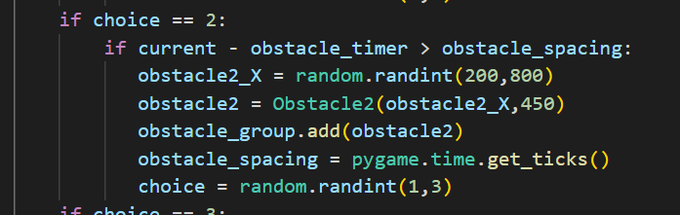

For testing purposes choice was set to a random number between 1 and 2

|  |  |
| --- | --- |
| **Testing For:** | **Results:** |
| Display Obstacle 2 (SC6) | Success |
| Obstacle 2 Correct Movement (SC6) | Success |
| Random Obstacle Generation (SC7) | Success |

Compared to the last test, during this test I also tested out to see if the obstacles were spawning randomly, and it was a success as seen in the table above

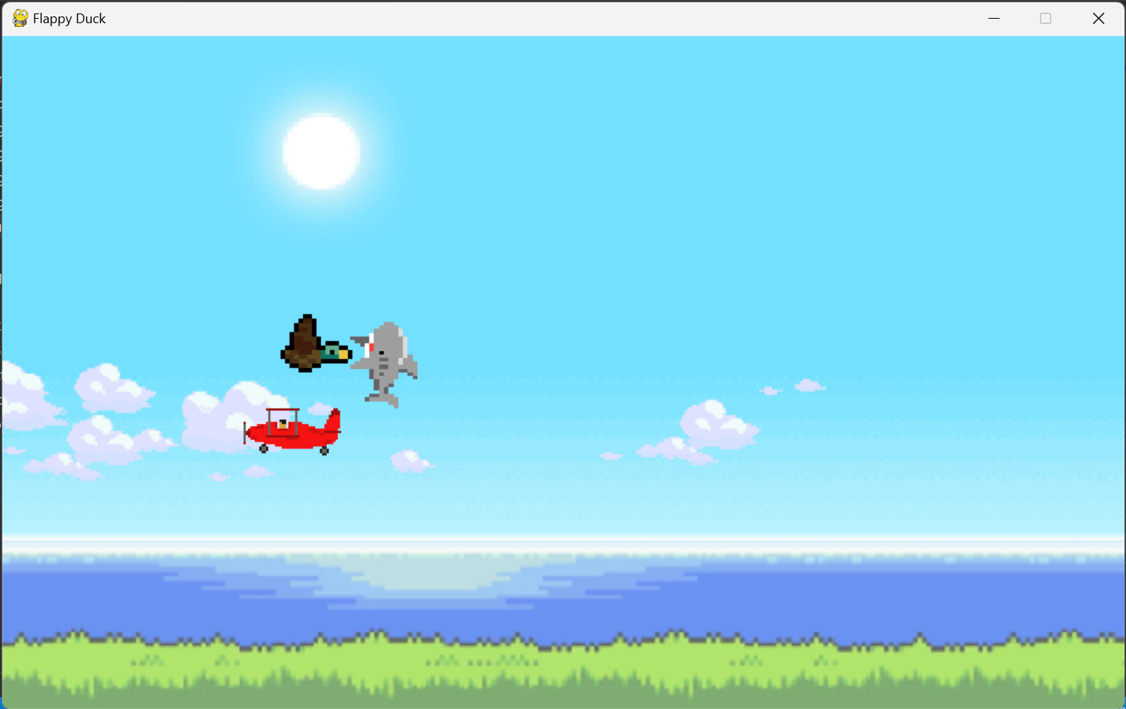

Similarly, to the other 2, I just used the same structure for my third obstacle. However, unlike the second obstacle I used the same integers as in obstacle 2 but had to change some variable names

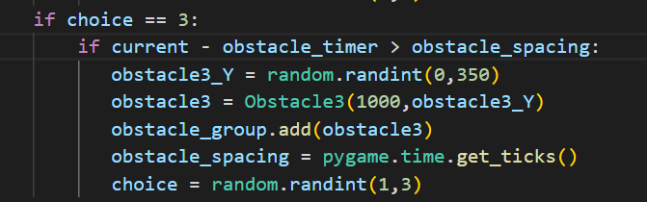

|  |  |
| --- | --- |
| **Testing For:** | **Results:** |
| Display Obstacle 3 (SC6) | Success |
| Obstacle 3 Correct Movement (SC6) | Fail |

During testing, an error with the third obstacle kept occurring where the obstacle would keep bugging out and bouncing too early or spawn in and keep bouncing in the same position. To fix this problem I first tried shortening the hitbox of the obstacle:

Before: After:

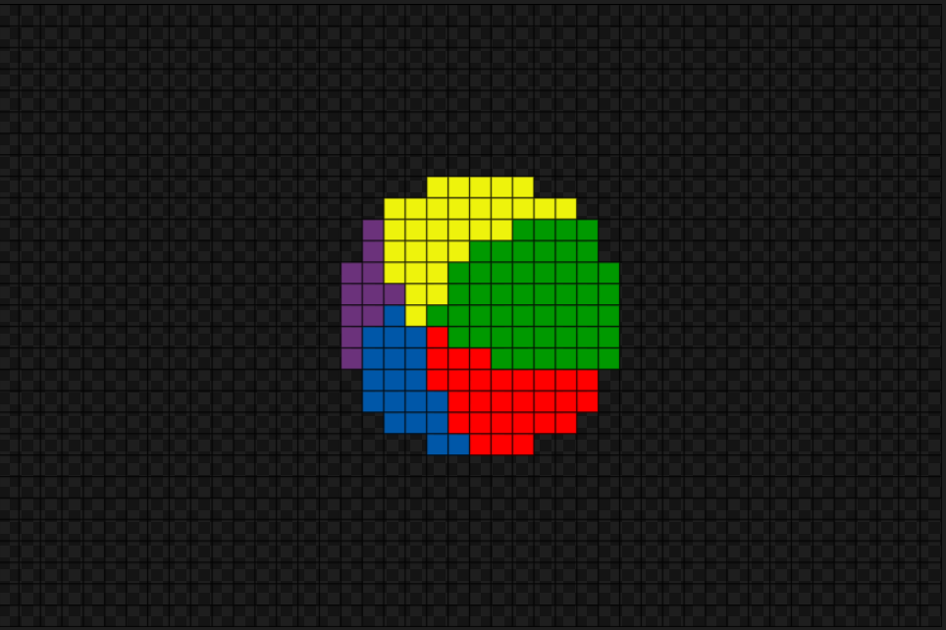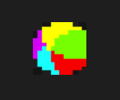

|  |  |
| --- | --- |
| **Testing For:** | **Results:** |
| Obstacle 3 Correct Movement (SC6) | Fail |

It has resolved the issue of randomly bouncing from the middle, however sometimes it still spawns in permanently bouncing and staying in on y coordinate. After debugging, I have come up with the solution of changing its spawn intervals.

From Obstacle 3 class I’ve changed the integer it bounces from



Another change I made was from the generate function, I increased the y value it can spawn in:



|  |  |
| --- | --- |
| **Testing For:** | **Results:** |
| Obstacle 3 Correct Movement (SC6) | Success |

SC7 Recap

Testing

|  |  |
| --- | --- |
| **Testing For:** | **Results:** |
| Display Obstacle 1 (SC6) | Success |
| Obstacle 1 Correct Movement (SC6) | Success |
| Interval Generation (SC7) | Success |
| Random Axis Generation (SC7) | Success |
| Display Obstacle 2 (SC6) | Success |
| Obstacle 2 Correct Movement (SC6) | Success |
| Random Obstacle Generation (SC7) | Success |
| Display Obstacle 3 (SC6) | Success |
| Obstacle 3 Correct Movement (SC6) | Success |

Extras

I had to change the outside file for the third obstacle to make its hitbox more reasonable

SC8

The last aspect the game is missing to make it playable is a loss condition, the loss condition in my game is when the player collides with an obstacle of the floor. When the loss condition is met the whole game will stop and in current development the user will not be able to continue but in future development the user will have to take action and click a button to restart the game

The first thing I must do before anything else is to create a new variable called gameEnd and store it in Boolean.

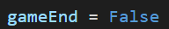

This variable will be used as a condition in parts of my game such as player movement, obstacle generation, etc.

The next necessary steps I must take to create the loss condition for my game is to adjust my Duck class to adjust some previous code that I made

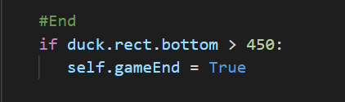

This will make it that when the duck hits the floor his velocity will be stopped and the duck won’t move anymore.

After this, I made a new function called End and called it in the main game loop, in this function I’m planning to integrate all the ways that cause a loss condition. First I made the function and globalised the variables it needed

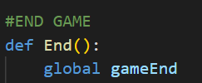

Even though I have already setup a condition for the floor in my Duck class, that variable in the duck class is not global and if the duck hits the floor it will only stop moving and not setup all the events that would occur if the loss condition is active, meaning that I also have to setup the floor loss condition in this function.

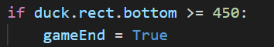

|  |  |
| --- | --- |
| **Testing For:** | **Result:** |
| gameEnd == True if player hits floor | Success |

The next loss condition is if the player collides with obstacles, to do this I used a function available with pygame when using sprite groups



This function allows me to check for collision between the player and all 3 obstacles within one line of code and returns True if collision occurs

|  |  |
| --- | --- |
| **Testing For:** | **Result:** |
| gameEnd == True if player hits obstacle | Success |

The game ended when the player collided with an obstacle, however the hitboxes were very weird with the obstacles. After some debugging it was the files from outside. I fixed the beachball hitbox but the other 2 hitboxes are still very big. To fix this all I had to do was shorten the png file.

Obstacle 1 new hitbox:

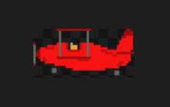

The hitbox is the checkboard background to the png

Obstacle 2 new hitbox:

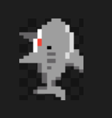

SC8 Recap

Testing

|  |  |
| --- | --- |
| **Testing For:** | **Result:** |
| gameEnd == True if player hits floor | Success |
| gameEnd == True if player hits obstacle | Success |

Extras

I had to remodel the obstacle pngs as tightly as possible so it contains all the design but no random extra space.

**Iteration 2 Recap**

Conclusion:

The goal of iteration 2 was reached. At the end of this iteration, a playable game was made which could easily be expanded upon. The gameplay is very smooth and immersive and reached a lot of goals I had for this project from the start. However, during the development I did have to remove a feature that would make the game more accessible/developed due to the fact that it wasn’t working correctly. Overall, Iteration 2 was a challenging iteration to code but when finished it creates a playtest version of my game which my stakeholders could experience and give me more feedback to further improve my game.

Testing:

|  |  |
| --- | --- |
| **Testing For:** | **Results:** |
| Duck Horizontal Movement | Success |
| Another Set of Inputs | Fail |
| Gravity | Success |
| Jump | Success |
| Display Obstacle 1 | Success |
| Obstacle 1 Correct Movement | Success |
| Interval Generation | Success |
| Random Axis Generation | Success |
| Display Obstacle 2 | Success |
| Obstacle 2 Correct Movement | Success |
| Random Obstacle Generation | Success |
| Display Obstacle 3 | Success |
| Obstacle 3 Correct Movement | Success |
| gameEnd == True if player hits floor | Success |
| gameEnd == True if player hits obstacle | Success |

Stakeholder Testing:

Friends: “Addicting game with a nice design theme, a better flappy bird for sure. It’s great right now but It’s a shame there’s only one control scheme”

Teachers: “A lot of high-level techniques involved in the coding, followed your project’s theme throughout. A high-grade project but still not enough content”

Family: “I don’t really play games but this games easy to understand and very fun to play, reminds me of that old game Flappy Bird”

Clients (that speak English): “From the playtest, the game is everything I envisioned it to be, the game developer sure does know what he is doing! If he finetunes the game this game could become a replacement for Flappy Bird. Some advice for future updates, please add a feature which allows me to instantly restart instead of me having to close the program and launching it again”

Clients (Foreign): “I don’t mean to be rude since it was just a playtest, but I thought the game was supposed to be challenging? Is this what people in England consider challenging? If so, please add some difficulty settings or something”

Feedback:

* Add more content to the game
* Add a feature which allows the user to press a button to restart the game instead of having to relaunch
* Add more challenge to the game
* If I have extra time, add more control schemes

**Iteration 3**

The goal of this iteration is to add the content to the base game and finetune it to become what the stakeholders want, to do this I will have to add quality of life updates, add more challenge to the game as right now its quite easy and is not what the solution was promised to be and also to add a feature to add competitiveness between others such as a score counter. At the end of this iteration, I want a fully published game that reaches all the goals I’ve set for this project.

To do this I will follow my success criteria from SC9 to SC11, as these contain the elements that I’m missing from my solution such as a score counter, restart button and “events” to add challenge to the game.

SC9

This segment’s objective is to fix a clear issue in my game, the only way to restart the game when you lose is to close the program then open it again. Which is not convenient for the users and the user loses immersion while doing this process. Hence, I will add a button that appears when the user loses which when clicks restarts the entire game

The first step was to adjust my End function and create a button object in it and do the same thing I did for my starting menu just change the event that would occur when the restart button is pressed

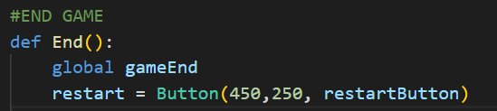

Now that I have created the object I need to create the event:

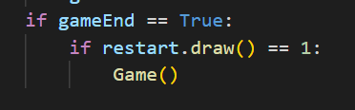

The theory is that if the game ended, display the restart button on the screen and if it is clicked it would call the Game function again

|  |  |
| --- | --- |
| **Testing For:** | **Results:** |
| Restart Button Display | Success |
| Restart the Game | Fail |

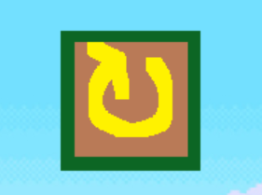

The restart button is displayed but when I click it nothing occurs, To fix the issue I am currently facing I added a extra event to when the button is clicked

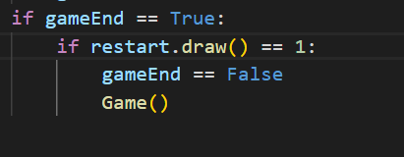

|  |  |
| --- | --- |
| **Testing For:** | **Results:** |
| Restart the Game | Fail |

This approach was not working for me therefore I had to change the way to execute this. Calling the Game function does not do the job so I decided to make a new function to call in place of Game called Restart

This Restart function will reset the position of the player so when the reset button is pressed it will start from the beginning and stop the player being stuck in a loss loop.

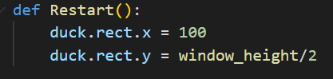

|  |  |
| --- | --- |
| **Testing For:** | **Results:** |
| Reset the Player | Fail |

After debugging, I noticed the users position didn’t change in the display as I did not call the End function in the draw function

|  |  |
| --- | --- |
| **Testing For:** | **Results:** |
| Reset the Player | Success |

Even though the player was reset, when the user pressed the restart button there were still obstacles in their current position so in the restart function I added a special function which comes with sprite groups which allows me to delete all the current obstacles on the screen



|  |  |
| --- | --- |
| **Testing For:** | **Results:** |
| Reset the obstacles | Success |
| Reset the Game | Success |

SC9 Recap

I will have to come back to the restart function in the future when I add more content to the game such as the score function.

Testing

|  |  |
| --- | --- |
| **Testing For:** | **Results:** |
| Restart Button Display | Success |
| Restart the Game | Success |
| Reset the Player | Success |
| Reset the Obstacles | Success |

Extras

Had to call the End function in draw function

SC10

My game was missing a huge feature which allows a game to be competitive and can creates goals for users and such. This is a way to beat the game, however my game is a game that cannot be beaten but a competitive game therefore, I will add a score system to promote users playing the game. To do this I will separate it into two different parts, the score counter itself and the way to gain score. I am doing this as it will help in my testing if errors occur.

The first step to making a score system is to make a variable that stores what the value of the score is:

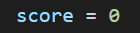

A problem I currently have is that I am missing an outside file to continue what I want to do. I don’t have a way to display text on the screen as I am missing a font file.



Added a fitting font that matches the flappy duck aesthetic into my files. Now I have to initialise it into my code



With all of this finished, I am going to make my score counter first thus I created a new function called Score_Counter and globalised the variable score

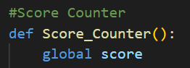

The next part was to write code to display the score in the format “Score:(score)”

But before I can display the score, I also forgot to add a colour code variable to be able to display the score:

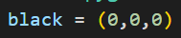

Score counter display:

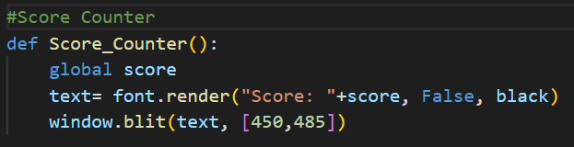

|  |  |
| --- | --- |
| **Testing For:** | **Results:** |
| Display Score | Fail |

The program crashes due to TypeError, to resolve this issue I changed the score variable in the text to a string.



|  |  |
| --- | --- |
| **Testing For:** | **Results:** |
| Display Score | Fail |

The score is not displaying. From debugging, I cannot figure out the issue therefore, to avoid wasting time I will come back to displaying the score in the future and work on adding the score first.

To add score, I will make a new function called Add_Score and I will use similar features I did for obstacle generation as the score in my game goes up for every 5 seconds you manage to live. Before I make the function I need to setup the tick loops:

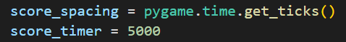

With this ready I can start creating my Add_Score function. In this function I will create a condition of every 5 seconds in ticks will add my score by 1 and reset the tick clock.

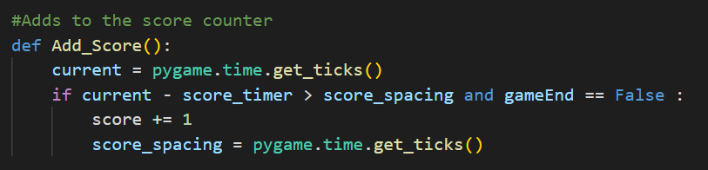

To do testing I will add a temporary line of code which will output the score alongside adding +1 to it.

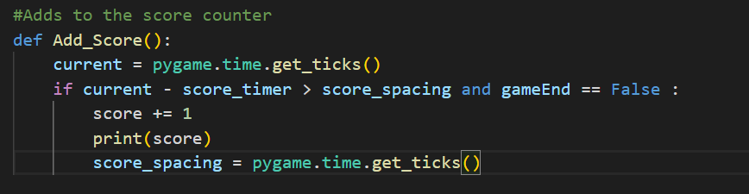

|  |  |
| --- | --- |
| **Testing For:** | **Results:** |
| Adding Score | Fail |
| Score Added in Intervals | Fail |

This was a quick fix, I forgot to globalise the variables used in the function:

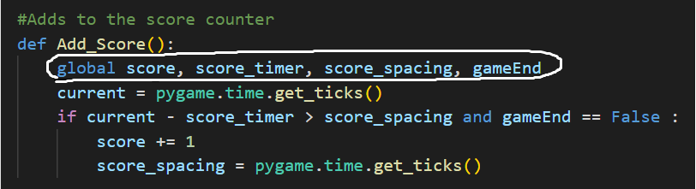

|  |  |
| --- | --- |
| **Testing For:** | **Results:** |
| Adding Score | Fail |
| Score Added in Intervals | Fail |

I forgot to implement the add score function into my main game loop, therefore I went my to my game loop and called Add Score there

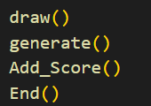

|  |  |
| --- | --- |
| **Testing For:** | **Results:** |
| Adding Score | Success |
| Score Added in Intervals | Success |

Console:

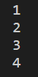

After fixing the problem with the Add Score function I reliased I was facing a similar problem with displaying the score counter as the score counter is made but it is not being called anywhere. But instead of calling it into the main game loop function I need to call it in the draw function

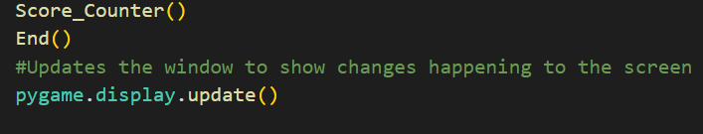

|  |  |
| --- | --- |
| **Testing For:** | **Results:** |
| Display Score | Success |

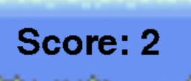

SC9 Continuation

Before I finish, I also need to adjust my restart function for it to reset the score whenever the restart button is clicked

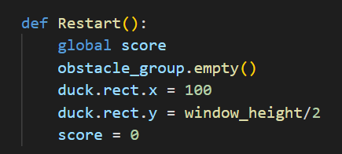

|  |  |
| --- | --- |
| **Testing For:** | **Results:** |
| Reset Score When Game Restarts | Fail |

The score was not resetting when the user clicked the restart button, to fix this I finetuned my End function and globalised score in there as well

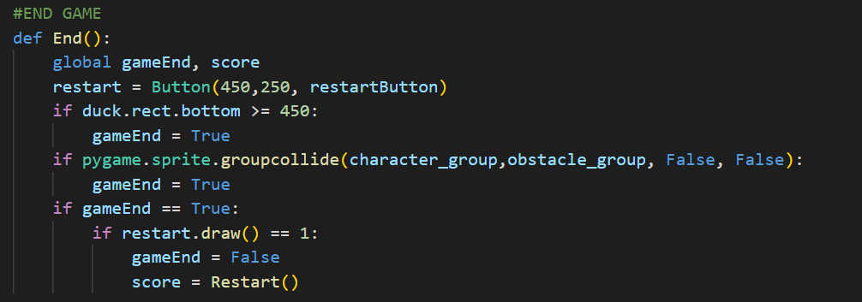

I turned score into the variable that holds the restart function and in the restart function I added a return value of the current score

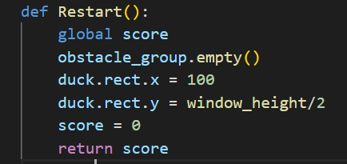

|  |  |
| --- | --- |
| **Testing For:** | **Results:** |
| Reset Score When Game Restarts | Success |

SC10 Recap

Testing

|  |  |
| --- | --- |
| **Testing For:** | **Results:** |
| Reset Score When Game Restarts (SC9) | Success |
| Display Score | Success |
| Adding Score | Success |
| Score Added in Intervals | Success |

Extras

I had to add a font outside file into my code and initiate it for it to be used in the program and had to add a new variable that stores a colour code for the colour black

SC11

The final part of my game which has not being introduced yet is the part that adds challenge and replay ability. I am doing this through a feature called events. Events are an action that take place one I reach a certain score interval and out of a list a certain event is chosen which will change the way the game continues and forces the user to adapt to their current situation based on what event they got.

I decided to make 3 different events to add into this game as I believe these 3 will make the game what me and the stakeholders wanted it to be.

Event 1:

* Reduce Obstacle spawning time making them spawn faster. This will increase the difficulty of the game as the user will have to dodge obstacles more often and pay more attention.

Event 2:

* Increase the Obstacles speed making them faster and harder to dodge. Instead of the put as many obstacles on the screen approach like event 1, this event goes for the each singular obstacle becomes more dangerous for the user.

Event 3:

* This event will add 1 point to the score, this is done to give the availability of reaching higher scores before the game becomes too challenging for some members of the game as this game is meant to beginner friendly and challenging and this fills the skill gap between the different type of users.

With my Events planned up, It’s time to integrate them into my game. To do this I will create a new function named Events and globalise all the variables that this function will need



With the function initliased, I also have to call it into my main game loop

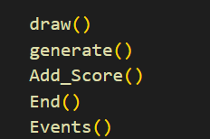

Since I want events to be chosen at random when a certain condition is met (when the user reaches 5 score) I will have to introduce the choice variable again and assign it a random number from 1 to 3

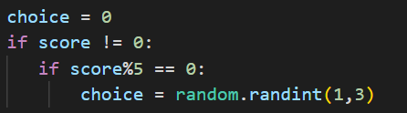

This piece of code checks if the score is not equal to 0 to prevent an event happening as soon as the game starts as python counts 0 a interval of 5. Then it checks if the score divisible by 5 and the remainder is 0 then it will give choice a random variable from 1 to 3 which then will trigger the next part of the code which will be a selection statement.

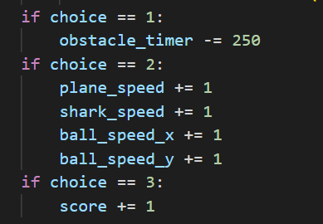

|  |  |
| --- | --- |
| **Testing For:** | **Results:** |
| Event Happens | Success |
| Event 1 Working as Intended? | Success |
| Event 2 Working as Intended? | Success |
| Event 3 Working as Intended? | Success |

While testing, I realised events take too long to occur. To make it a smoother and better experience I am it from 5 to 2 seconds for the user to gain one extra score point.

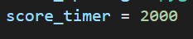

With this, Events are implemented into my game and working with correct functionality. However, when the game restarted the result of the events were still active therefore I will need to go back to SC9

SC9 Continuation

I added all the extra variables which change during the game and reset their value to their base value when Restart function is ran:

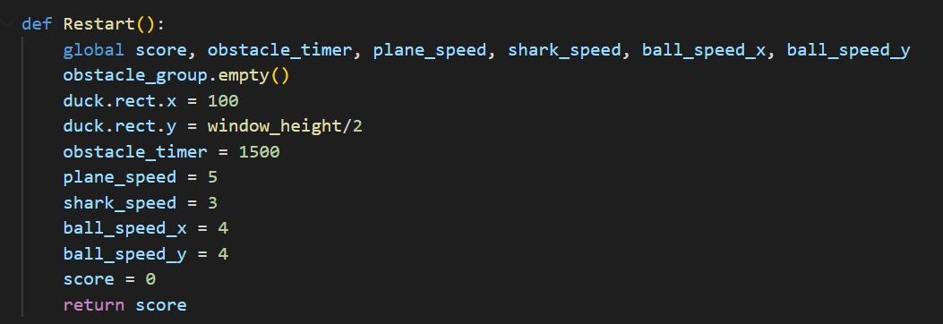

|  |  |
| --- | --- |
| **Testing For:** | **Results:** |
| Game fully resets when restart button is pressed | Success |

SC11 Recap

Testing

|  |  |
| --- | --- |
| **Testing For:** | **Results:** |
| Event Happens | Success |
| Event 1 Working as Intended? | Success |
| Event 2 Working as Intended? | Success |
| Event 3 Working as Intended? | Success |
| Game fully resets when restart button is pressed | Success |

Extras

Changed the tick time taken to receive a score point from 5 to 2 seconds.

**Iteration 3 Recap**

Conclusion:

The goal of iteration 3 was to turn my base game into the game I promised to deliver to my stakeholders. From a playtest to a finished publishable game. I added all the content my stakeholders wanted to see from Iteration 2 therefore Iteration 3 has been a huge success development wise. However, I did not have enough time to fix the issue with multiple control schemes. Overall, in this iteration I made my game have factors of competitiveness which promotes users facing off against each other to see who’s better, added extra challenge to the game as the game is meant to be a challenging game but with this challenge I also took precautions not to ruin the game for more beginner friendly chill users. And finally I added quality of life features which are essential in any project as the more convenient/smooth a program is to use the higher the appreciation the project gets.

Testing:

|  |  |
| --- | --- |
| **Testing For:** | **Results:** |
| Restart Button Display | Success |
| Restart the Game | Success |
| Reset the Player | Success |
| Reset the Obstacles | Success |
| Reset Score When Game Restarts | Success |
| Display Score | Success |
| Adding Score | Success |
| Score Added in Intervals | Success |
| Event Happens | Success |
| Event 1 Working as Intended? | Success |
| Event 2 Working as Intended? | Success |
| Event 3 Working as Intended? | Success |
| Game fully resets when restart button is pressed | Success |

Stakeholder Testing:

Friends: “A game that is great to play when I have nothing else to do and decide to pass sometime. Only big problem is that the game can sometimes be too addictive but if anything that makes the game more recommendable to people who need a source of entertainment from time to time”

Teachers: “Well made project, showcases a lot of programming skills and the code is written like a professional with the use of functions and classes allowing the code to be reused for future projects. Only complain I have is that for this project it may be too short but great skills were shown so I can see past that”

Family: “First time playing a mobile game and It wasn’t too hard to understand and even though it was challenging, it was also welcoming and easy to understand!”

Clients (that speak English): “Does not disappoint is the best way to put it. If you were invested into this game then you got what you wanted. Addictive, challenging and competitive. Everything I looked for in this game. I would give it a 9/10 since there are some elements that could be improved but is a must try for people looking for a better version of Flappy Bird”

Clients (Foreign): “I love it, The game is so simple but beautiful, bland but elegant, rough but smooth, provoking but immersive. Simply magnificent”

**Stakeholder Signatures:**

Friend used = Bukayo Havertz

Teacher used = Rahman Mohammed

Family used = mother

Client (English) used = Kai Saka

Client (Foreign) used = Raheem Felix

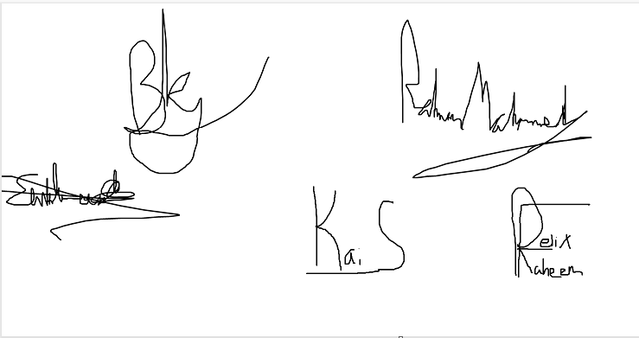

**Code:**

#Importing Modules to use in my code

from turtle import window_height, window_width

import pygame

from pygame.locals import *

import random

#Initialises pygame so it can be used

pygame.init()

#Locks the game to a certain framerate

clock = pygame.time.Clock()

fps = 60

#Variables for Window

window_width = 1000

window_height = 600

window = pygame.display.set_mode((window_width,window_height))

pygame.display.set_caption("Flappy Duck")

#Variables for Game

scrolling_floor = 0

scrolling_speed = 3

birdStart = False

gameEnd = False

obstacle_spacing = pygame.time.get_ticks() - 2000

obstacle_timer = 1500

plane_speed = 5

shark_speed = 3

ball_speed_x = 4

ball_speed_y = 4

font = pygame.font.SysFont("ScoreFont.ttf", 50)

black = (0,0,0)

score = 0

score_spacing = pygame.time.get_ticks()

score_timer = 2000

#Load Images

background = pygame.image.load("background.png")

floor = pygame.image.load("floor.png")

menu = pygame.image.load("menu.png")

startButton = pygame.image.load("startbutton.png")

closeButton = pygame.image.load("closebutton.png")

restartButton = pygame.image.load("restartbutton.png")

#Starter Menu

def GameMenu():

   window.blit(menu,(0,0))

   start = Button(200,400, startButton)

   close = Button(650,400, closeButton)

   run = True

   while run:

     for event in pygame.event.get():

         if event.type == pygame.QUIT:

            run = False

         if start.draw() == True:

            Game()

         if close.draw() == True:

             pygame.quit()

         pygame.display.update()

#Button Class

class Button():

    def __init__(self,x,y,image):

        #Creates the button

        self.image = image

        self.rect = self.image.get_rect()

        self.rect.topleft = (x,y)

        self.clicked = False

    def draw(self):

        #Variable to Customise Result of button

        event = False

        #gets mouse position on the screen

        mousePosition = pygame.mouse.get_pos()

        #Condition to Activate Button

        if self.rect.collidepoint(mousePosition) and pygame.mouse.get_pressed()[0] == 1 and self.clicked == False:

            self.clicked = True

            event = True

        #Puts the button onto the screen

        window.blit(self.image, (self.rect.x,self.rect.y))

        return event

#Duck Class

class Duck(pygame.sprite.Sprite):

    #Initiliases the Class

    def __init__(self,xvalue,yvalue):

        pygame.sprite.Sprite.__init__(self)

        #List of all sprites related to animation

        self.animation = []

        #Index stores which item it is on the list

        self.index = 0

        #Counter counts when it needs to switch index

        self.counter = 0

        #Loads the ducks sprite in animation form

        for animation in range(1,5):

            #Loads the image currently used for animation

            ani_img = pygame.image.load(f"duck{animation}.png")

            #Makes the image suitable size/direction for the game

            ani_img = pygame.transform.scale(ani_img,(64,64))

            ani_img = pygame.transform.flip(ani_img,90,0)

            #Adds the image into the animation list

            self.animation.append(ani_img)

        #Finds which image to load in the list

        self.image = self.animation[self.index]

        #Creates a hitbox around the image

        self.rect = self.image.get_rect()

        #The center of the sprite

        self.rect.center = [xvalue, yvalue]

        self.velocity = 0

        self.mouseClick = False

    def update(self):

        #Counts up until anicd to switch image from the animation list

        self.counter += 1

        anicd = 8

        #Resets counter and goes to the next image in the list

        if self.counter > anicd:

            self.counter = 0

            self.index += 1

            #Once index reaches the end of the list resets it to the front

            if self.index >= len(self.animation):

                self.index = 0

        #Finds which image to load in the list

        self.image = self.animation[self.index]

        #End

        if duck.rect.bottom > 450:

           self.gameEnd = True

        #Gravity

        if birdStart == True:

           self.velocity += 2

           if self.velocity > 2:

               self.velocity = 2

           if self.rect.bottom < 450:

              self.rect.y  += self.velocity

        #Jump

        if gameEnd == False:

           if pygame.mouse.get_pressed()[0] == 1 and self.mouseClick == True:

               self.velocity = -15

               self.mouseClick = False

        #Prevents the mouse just being held

        if pygame.mouse.get_pressed()[0] == 0 and self.mouseClick == False:

            self.mouseClick = True

        #Sets Up a Roof

        if self.rect.top < 0:

            self.rect.y -= self.velocity

        #Left, Right Movement

        if gameEnd == False:

            #Left

            if pygame.key.get_pressed()[pygame.K_a]:

               self.rect.x -= 5

            if self.rect.left < 0:

               self.rect.x += 5

            #Right

            if pygame.key.get_pressed()[pygame.K_d]:

               self.rect.x += 5

            if self.rect.right > 1000:

               self.rect.x -= 5

#Obstacles Class

class Obstacle1(pygame.sprite.Sprite):

    #Initiliases the Class

    def __init__(self,xvalue,yvalue):

        pygame.sprite.Sprite.__init__(self)

        self.image = pygame.image.load("Obstacle1.png")

        self.rect = self.image.get_rect()

        self.rect.topleft = [xvalue, yvalue]

    def update(self):

        self.rect.x -= plane_speed

class Obstacle2(pygame.sprite.Sprite):

    #Initiliases the Class

    def __init__(self,xvalue,yvalue):

        pygame.sprite.Sprite.__init__(self)

        self.image = pygame.image.load("Obstacle2.png")

        self.rect = self.image.get_rect()

        self.rect.topleft = [xvalue, yvalue]

    def update(self):

        self.rect.y -= shark_speed

class Obstacle3(pygame.sprite.Sprite):

    #Initiliases the Class

    def __init__(self,xvalue,yvalue):

        pygame.sprite.Sprite.__init__(self)

        self.image = pygame.image.load("Obstacle3.png")

        self.rect = self.image.get_rect()

        self.rect.topleft = [xvalue, yvalue]

    def update(self):

        global ball_speed_x,ball_speed_y

        self.rect.x -= ball_speed_x

        self.rect.y -= ball_speed_y

        if self.rect.top <= 0 or self.rect.bottom >= 500:

            ball_speed_y *= -1

#Sprite Groups

character_group = pygame.sprite.Group()

duck =  Duck(100,(window_height/2))

character_group.add(duck)

obstacle_group = pygame.sprite.Group()

#Draw Function

def draw():

    #Allows variables to be assigned/used outside function

    global scrolling_floor, scrolling_speed

    #Draws the images/sprites into the window

    window.blit(background, (0,0))

    window.blit(floor, (scrolling_floor,450))

    #Scrolling Background

    scrolling_floor -= scrolling_speed

    if abs(scrolling_floor) > 1000:

        scrolling_floor = 0

    #Draws the Sprites in the group

    character_group.draw(window)

    character_group.update()

    obstacle_group.draw(window)

    obstacle_group.update()

    Score_Counter()

    End()

    #Updates the window to show changes happening to the screen

    pygame.display.update()

#END GAME

def End():

    global gameEnd, score

    restart = Button(450,250, restartButton)

    if duck.rect.bottom >= 450:

        gameEnd = True

    if pygame.sprite.groupcollide(character_group,obstacle_group, False, False):

        gameEnd = True

    if gameEnd == True:

        if restart.draw() == 1:

            gameEnd = False

            score = Restart()

def Restart():

    global score, obstacle_timer, plane_speed, shark_speed, ball_speed_x, ball_speed_y

    obstacle_group.empty()

    duck.rect.x = 100

    duck.rect.y = window_height/2

    obstacle_timer = 1500

    plane_speed = 5

    shark_speed = 3

    ball_speed_x = 4

    ball_speed_y = 4

    score = 0

    return score

#Obstalce Generation

def generate():

    global gameEnd, birdStart, obstacle_timer, obstacle_spacing

    if gameEnd == False and birdStart == True:

        current = pygame.time.get_ticks()

        choice = random.randint(1,3)

        if choice == 1:

           if current - obstacle_timer > obstacle_spacing:

               obstacle1_Y = random.randint(0,350)

               obstacle1 = Obstacle1(1000,obstacle1_Y)

               obstacle_group.add(obstacle1)

               obstacle_spacing = pygame.time.get_ticks()

               choice = random.randint(1,3)

        if choice == 2:

            if current - obstacle_timer > obstacle_spacing:

               obstacle2_X = random.randint(200,800)

               obstacle2 = Obstacle2(obstacle2_X,450)

               obstacle_group.add(obstacle2)

               obstacle_spacing = pygame.time.get_ticks()

               choice = random.randint(1,3)

        if choice == 3:

            if current - obstacle_timer > obstacle_spacing:

               obstacle3_Y = random.randint(0,400)

               obstacle3 = Obstacle3(1000,obstacle3_Y)

               obstacle_group.add(obstacle3)

               obstacle_spacing = pygame.time.get_ticks()

               choice = random.randint(1,3)

#Score Counter

def Score_Counter():

    global score

    text= font.render("Score: "+str(score), False, black)

    window.blit(text, [450,485])

#Adds to the score counter

def Add_Score():

    global score, score_timer, score_spacing, gameEnd

    current = pygame.time.get_ticks()

    if current - score_timer > score_spacing and gameEnd == False :

        score += 1

        score_spacing = pygame.time.get_ticks()

#Events that occur when a certain score is reached

def Events():

    global score, plane_speed, shark_speed, ball_speed_x, ball_speed_y, obstacle_timer

    choice = 0

    if score != 0:

       if score%5 == 0:

           choice = random.randint(1,3)

    if choice == 1:

        obstacle_timer -= 250

    if choice == 2:

        plane_speed += 1

        shark_speed += 1

        ball_speed_x += 1

        ball_speed_y += 1

    if choice == 3:

        score += 1

#The Main Game Loop

def Game():

   global birdStart, gameEnd

   #Variable that decides if the game is on or off

   run = True

   #Game Loop

   while run:

    for event in pygame.event.get():

        if event.type == pygame.QUIT:

            run = False

        if event.type == pygame.MOUSEBUTTONDOWN and birdStart == False and gameEnd == False:

            birdStart = True

        if event.type == pygame.KEYDOWN and birdStart == False and gameEnd == False:

            birdStart = True

    draw()

    generate()

    Add_Score()

    End()

    Events()

    clock.tick(fps)

   pygame.quit()

#Main Code

GameMenu()

**Final Pictures of my Game:**

Start Menu:

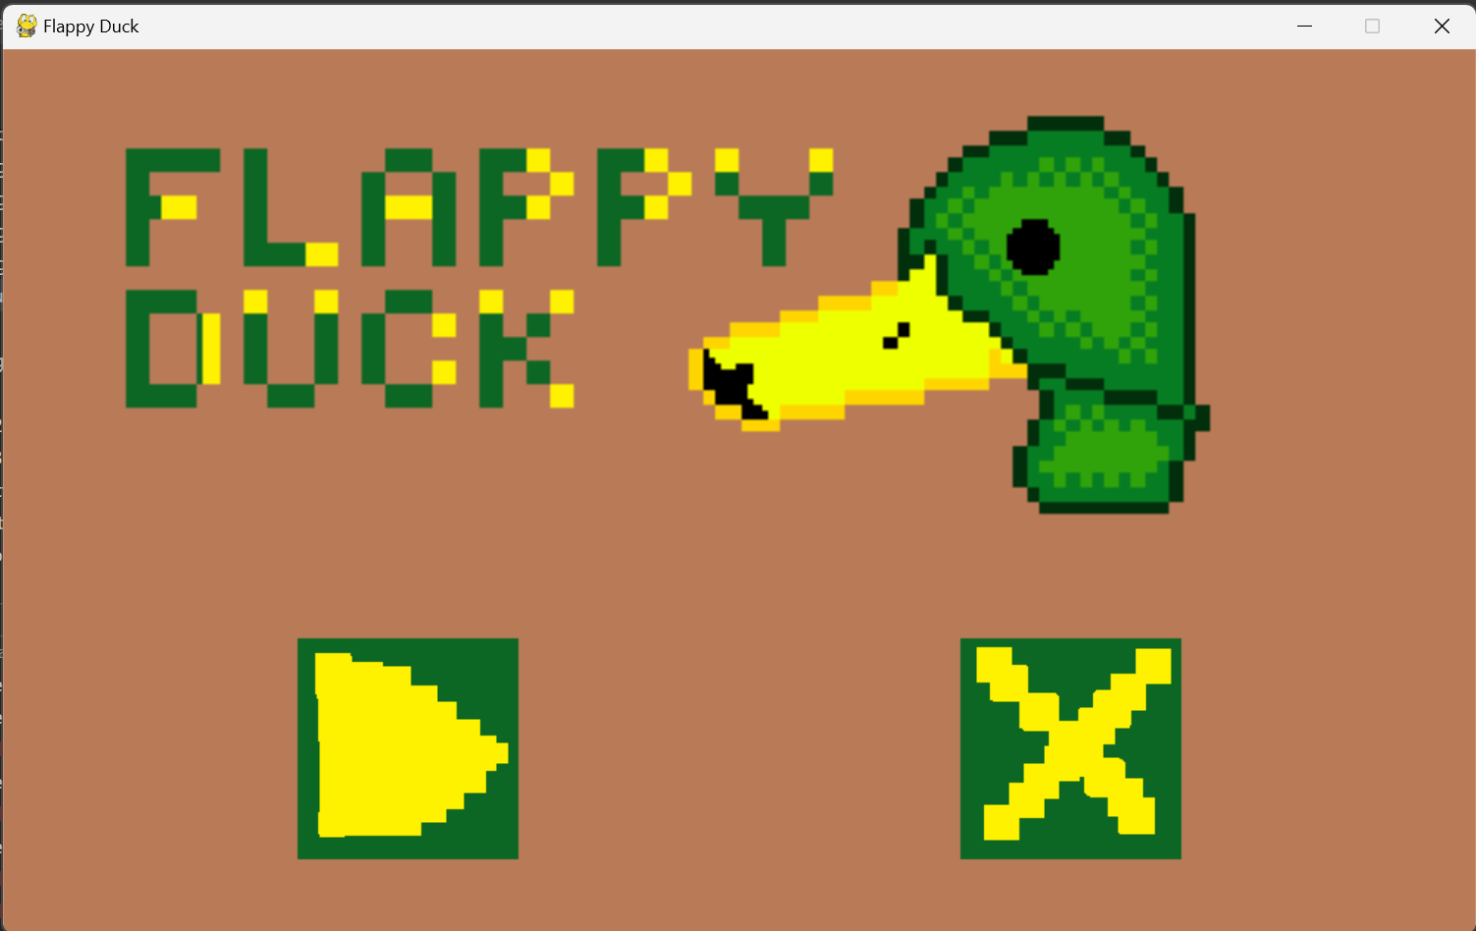

Game Screen:

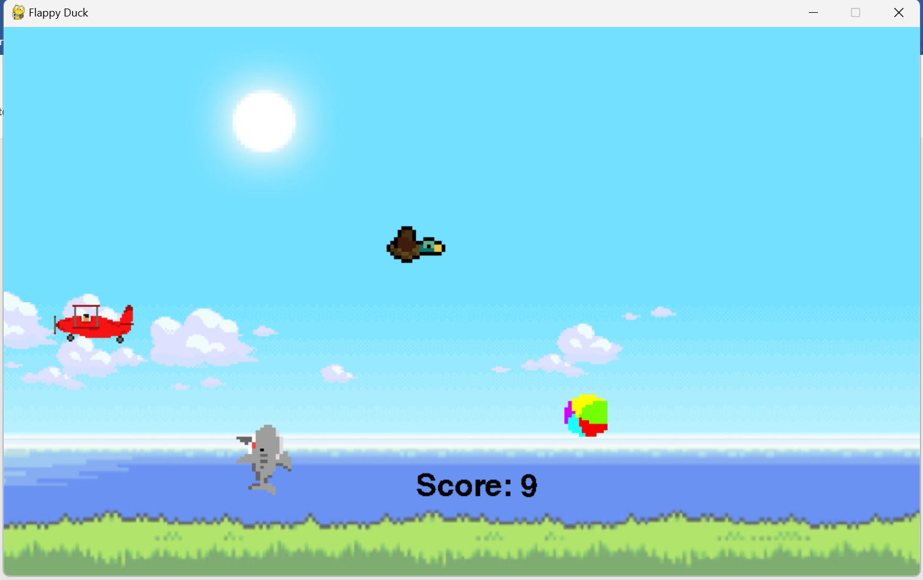

Death Screen:

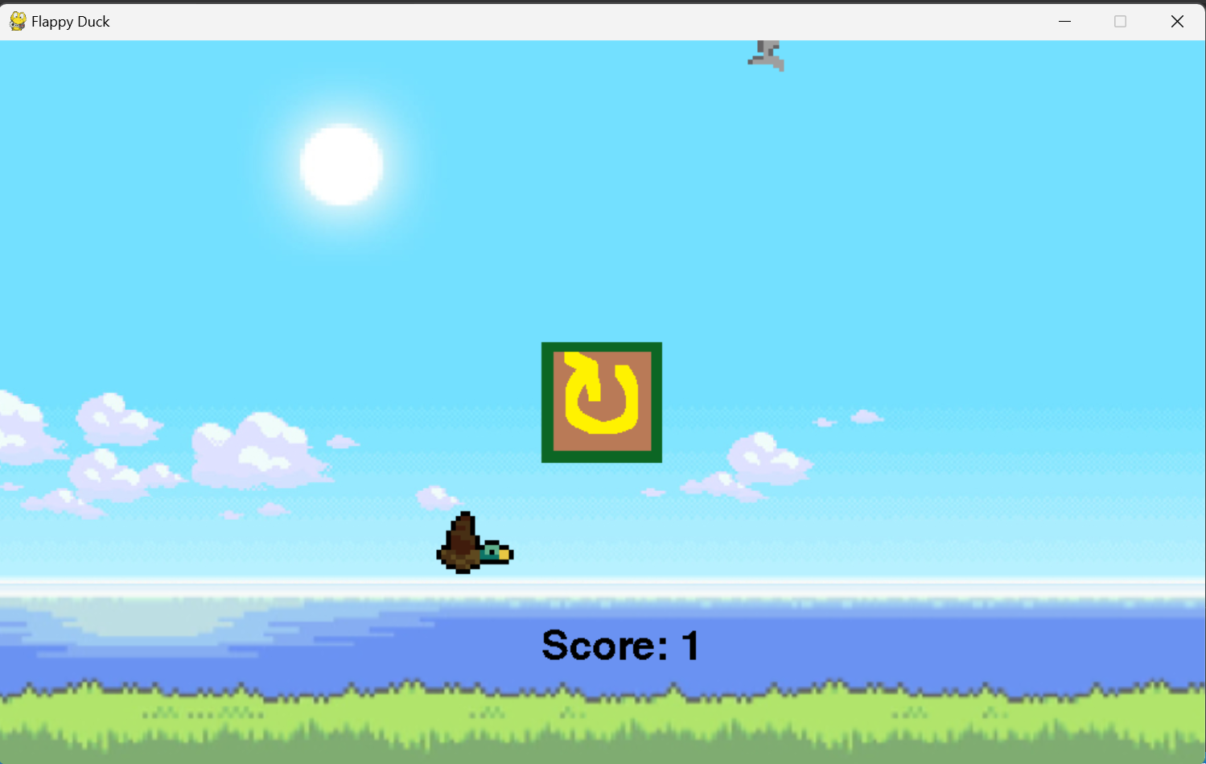

**Outside Files used:**

Background(From Pinterest)

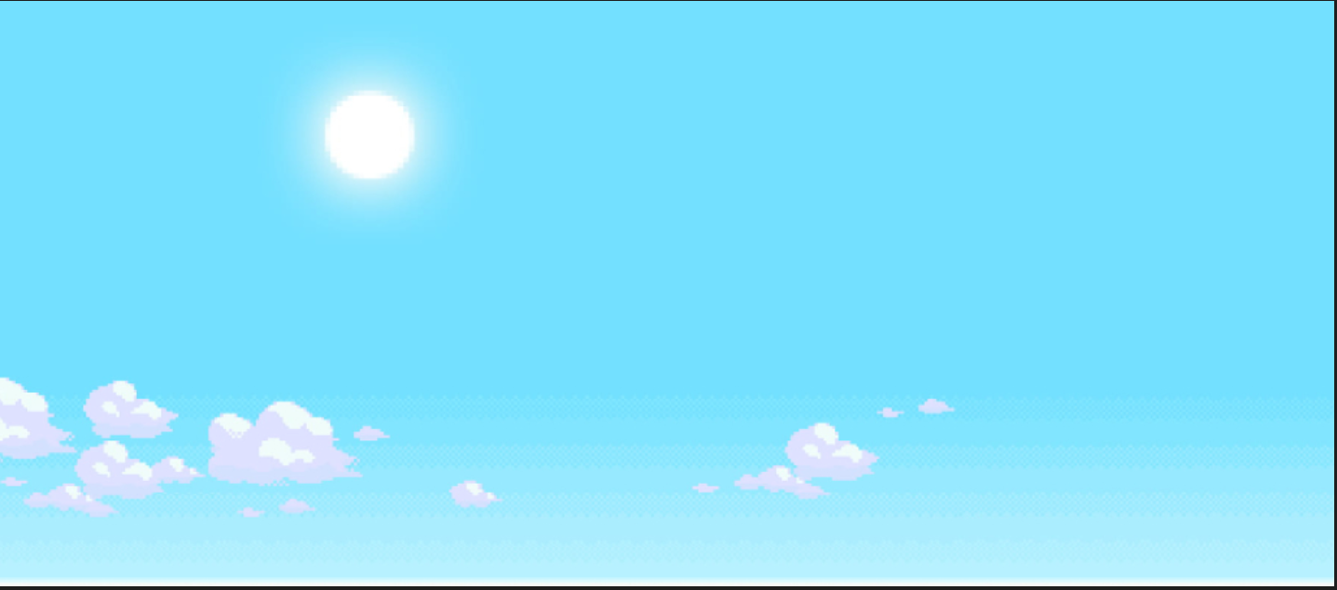

Duck(From OpenGameArt)

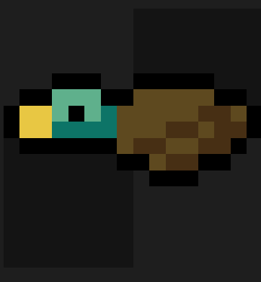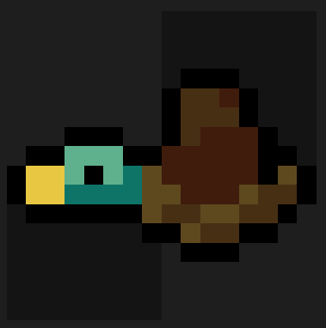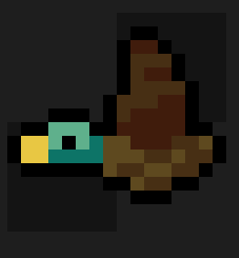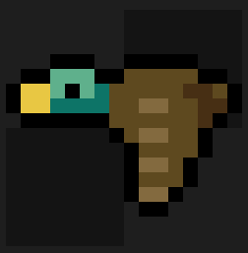

Floor(From Pinterest)

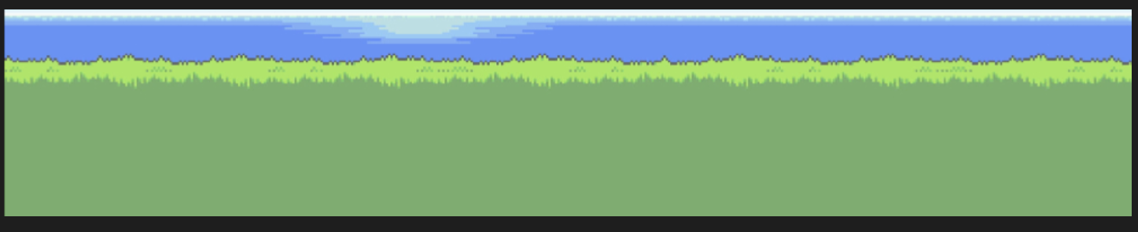

Obstacles (From OpenGameArt)

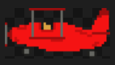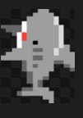 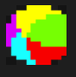

Starting Menu (I made it)

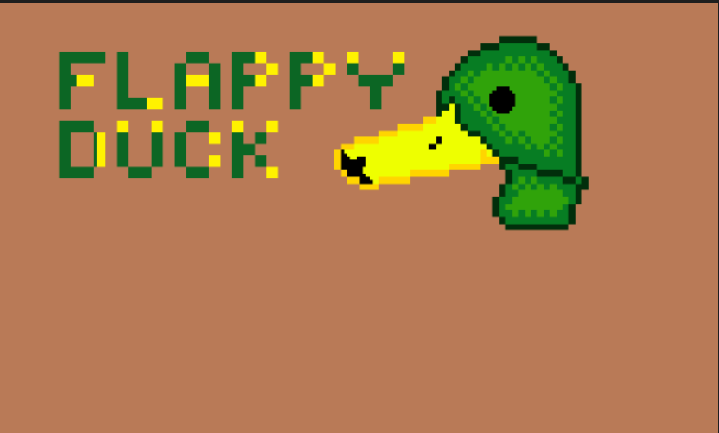

Buttons (I made them)

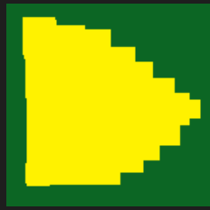  

ScoreFont (From Dafont)



**Evaluation**

The final version of my program had most of the features and specifications that my stakeholders/users wanted. But due to time limitations, I wasn’t able to improve these features to the extent I had originally planned. I will go through each of the requirements (Success Criteria) and explain what my starting goal was compared to the outcome.

1. A Window named “Flappy Duck” which opens when the game is run

This one is self-explanatory. I have achieved this goal to the maximum since it’s a linear problem as it’s a simple problem which can’t really be improved any further therefore this has been fully implemented into my game in the state I/users had envisioned. I had decided to make the window 1000x600 as those are the perfect dimensions to make the game challenging/not too clustered. (Evidence on Development, Iteration 1, SC1)

1. A Starting Menu that allows the users to press play and start the game or press Exit and leave the game

The initial goal was a starting menu which just allowed the user to get into the game or close the game. This goal was indeed met but extra features I wanted to add during development were not made due to time limitations. These features included a button to see the control schemes and a display of a high score which was also not added. Overall, the goal was met but there was possible additions I could’ve made to make my game more understanding and accessible/competitive. (Evidence on Development, Iteration 1, SC2)

1. Set a background with a scrolling floor below it

This was another straightforward goal which could not be expanded upon therefore when developing my game I completed this goal to the maximum. The background is a fitting background for the game which adds extra immersion especially with the fitting moving background which allows the emulation of a duck flying over the sea during sunrise. (Evidence on Development, Iteration 1, SC3)

1. Draw a Duck sprite on the screen in the middle left and setup a hitbox/rectangle around it

This goal was met by creating a class as this was the most efficient/simple way to achieve my goal and showcases extra skill. This goal was met completely and finished in its definitive state. (Evidence on Development, Iteration 1, SC4)

1. Setup movement: A jump button which when pressed makes the duck sprite go up fluently and make the duck constantly go down when the jump button is not pressed

This goal is very controversial according to my stakeholders, in a positive and negative way. The feature of a jump and gravity was added into my game, however, different control schemes which was promised did not come into the game. This was due to coding errors and was dropped but as a replacement, allowing the user to move left and right was introduced which has been received very positively. (Evidence on Development, Iteration 2, SC5)

1. Draw obstacles and set up hitboxes/rectangles around it. Define its movement as well (Minimum 3)

The goal which is described was met however, originally, I was going to add more obstacles to increase challenge, replay ability and content into my game. But lack of ideas has prevented me from adding more. In conclusion, the goal was met but could’ve been improved a lot more to increase substance to my solution. (Evidence on Development, Iteration 2, SC6)

1. Generate obstacles randomly on the right side of the screen or above the floor, random area, and random obstacle

This was met to the maximum extent and is one of the most impressive parts of my development. I spent most of my time in development on this section as I deemed it the most important to create a meaningful solution which would be labelled satisfactory by my stakeholders/users. (Evidence on Development, Iteration 2, SC7)

1. Create a way for the duck to die resulting in the user losing

Another simple objective which was linear and met. Not much could be improved from the way I defined this objective in my solution as it’s a basic and simple goal but necessary for my solution (Evidence on Development, Iteration 2, SC8)

1. Replay button on the death menu which restarts the code and allows the user to go again without reopening and a button to go back to the main menu

This goal was half met as I created the replay button functional and fully resets the game variables without resetting the entire program. However I did not reach one of my goals of adding a button to go into the main menu due to time limitations (Evidence on Development, Iteration 3, SC9)

1. Add a score system which is displayed on the top of the screen which increments +1 score every 5 seconds the user survives after pressing the start/replay button.

This goal was not only met but improved as I changed the score system to be displayed at the bottom of the screen which is a place which is easy to view for the user without getting in the way of the users “play” area part of the screen. I also reduced the amount of seconds from 5 to 2 to quicken the pace of the game and make events occur faster to add extra challenge.

1. Add random events (Minimum 2) Which when reaching a certain score take effect

I implemented 3 unique events with all their own purpose which help any type of user as these events add more challenge, add a little bit of a gamble and make the game more engaging and encourages users to adapt to their current situation based on the events they gain as events stack on each other giving the game a lot of replay ability as each game will feel different the further you are into a run. This goal was met to high standards and better implemented then initially planned.

|  |  |  |
| --- | --- | --- |
| **Success Criteria** | **Met?** | **Improved?** |
| 1 | ✓ | # |
| 2 | ✓ | X |
| 3 | ✓ | # |
| 4 | ✓ | ✓ |
| 5 | ✓ | ✓ (Changed for the better) X (missing extra control schemes) |
| 6 | ✓ | X |
| 7 | ✓ | # |
| 8 | ✓ | # |
| 9 | X | X |
| 10 | ✓ | ✓ |
| 11 | ✓ | ✓ |

✓ = Yes X = No # = Could Not

Problems I faced during Development:

The biggest problem I faced was usually time management as seen with SC9 as I had to split my time up and put more time into parts of the solution I thought were more important meaning I did not have enough time to finish/improve certain parts of my solution. Another problem I faced was shown during SC6 where I lacked ideas of obstacles that were within my skillset to code. I had thought of some but I wanted all my obstacles to be unique and different.

Limitations:

* Control Scheme: Only one control scheme in the game currently and no way to view the control scheme itself meaning first time users of my solution will need to figure it out or search it up which is not ideal for convenience and accessibility as they were key factors during my development of the game
* When the loss condition is met in the game, the user only gets an option of replaying and there is no way to go back to the starting screen to be able to leave the game reducing accessibility and less convenient for users
* Amount of content: The game does offer a lot of replay ability, but there is no features that encourage the user to keep playing the game so even with great replay ability the user can get bored and stop playing the game or even drop the game entirely
* No International Competition: The game does not offer leader boards / high scores right now meaning there is no way to track competition or compete with others which you do not know in real life

Improvements:

* High Scores: this is a feature currently missing and keeps a track of the users best score and is displayed in the main menu. This can be achieved by simply adding a new variable which stores the result first achieved then comparing it to current run results and if its bigger then the current run result becomes the new best result. To save it from different times the program is ran it could save it into a outside file.
* Leaderboards: this feature will promote competitiveness between users from around the world and will be able to be viewed from the start menu through a button click. It will show the top 50 players high scores. This can be achieved using a database and whenever a high score higher then one of the top 50 players is reached it will update the database to put it in its correct position
* More obstacles: this is a simple addition which will add more replay ability and add extra challenge as more obstacles add more skill gap to the game which could result is users playing the game more to learn.
* Extra gamemodes: for example adding a mode where the user has to collect a piece of duck food to gain a point instead of surviving 2 seconds while obstacles work the same. With extra gamemodes this will attract more users to the game and split up competition to give users more places to compete. It also is more content which will result in people playing the game more often
* Events: Events is lacking accessibility right now as when an event happens there is no signal apart from what changed in the game of what event occurred meaning for beginners it may be hard or confusing to understand what’s going on. To change this and help the beginner-friendly experience I could add specific text that appears depending on what event happens. This can be done by simply blitting text for a certain amount of time when an event occurs.
* Coin/Shop: This is a simple feature where the user can collect coins from playing game modes which can be spent in the shop. The shop will contain skins for the duck which the user can collect. However, coins will not be the only way to earn the skins and certain skins can be achieved by reaching score milestones.
* Area Cycling: Every score interval, the user changes area changing the look of the background/floor and obstacles to keep the game feeling fresh throughout a run and not keeping the same sprites as this can become quite stale over a lot of runs/ long runs. This can be done by when reaching a score interval blitting new sprites/png files over.

Usability:

Interface – My solutions interface is very easy to understand by anyone, there is no language barriers as the interactable parts of my interface are universal symbols which can be understood by anyone around the world. The interface is also quite straightforward as what you click is what you get and there is not too many actions in the interface making it understandable instead of overwhelming.

Objective – My solution has a very clear objective which can be understood by playing a singular run and my objective stays the same throughout meaning once you understand it then the objective becomes a task to follow instead of a task to figure out.

Visuals – My solutions visuals are fitting to my game and very simple so its not too intensive on the user while playing the game and my stakeholders claimed it had its own “charm” to it enhancing the experience. The graphics are also very light meaning it can be basically played on any computer without difficulty of running the game.

Difficulty – My solutions difficulty embraces both beginners and experienced users as the game is very easy to control and starts off with a simple game like Flappy bird but the further you are into a run the difficulty multiplies creating an environment where experienced users can enjoy using the program.

Overall, My solutions contains a lot of thought into usability and allowing anyone to use the solution and still enjoy using it. However, some extra usability features that could be added in the future is instead of buttons add a menu which allows the user to change the language to the one they want allowing even more users to understand. This will help some users who might not understand universal symbols.